Two-Factor Authentication (2FA) Setup and Login for CAREWare 6

Two-factor authentication (2FA) in CAREWare 6 is a quick and powerful way to increase the security of the CAREWare user login process. Please follow the steps below:

- The following devices are compatible:
  - iPhone
  - Android Smartphone

- Setting up a smartphone with Google Authenticator application:
  - Install the Google Authenticator app (this is a free app) from your app store.
    - Android Phones: Google Play Store
    - iPhones: App Store – Apple
  - When you have completed installation of Google Authenticator on your cell phone, use your computer (Chrome, Firefox, or Microsoft Edge browsers will work) and go to: https://indycw.ixn.com
    - Log in to CAREWare 6 using the username and password that you most recently used for CAREWare 5. (Do not use RD Web when logging in to CAREWare 6)
    - You will be presented with a screen that looks like this (your username will be displayed instead of cwtemp)
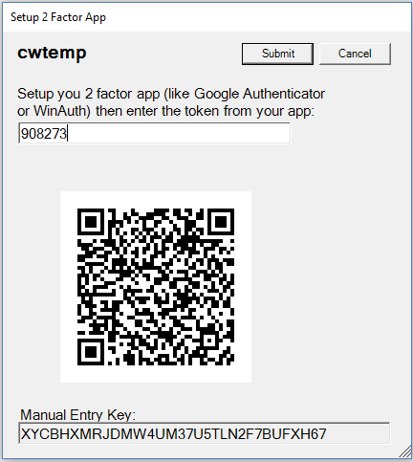
  - Open Google Authenticator on your smartphone
  - Press the red circle with a plus sign on it
  - Choose Scan a Barcode
  - Point the phone camera at the barcode on the computer screen
  - The barcode will register, you will see your CAREWare account along with a 6 digit number next to it. You will also see a small animated pie chart that gets smaller until it disappears. Once the pie disappears, a new pie will appear, along with a new number. The pie chart gives you visual cue of the time window that the current number is valid.
  - Enter the code within the valid time window and click on submit.

- Logging into CAREWare
  - The next time you login to CAREWare 6, you will be prompted for your 2 factor key.
  - Open Google Authenticator and wait until the pie chart indicator is full.
  - Enter the number.
  - Click Submit

