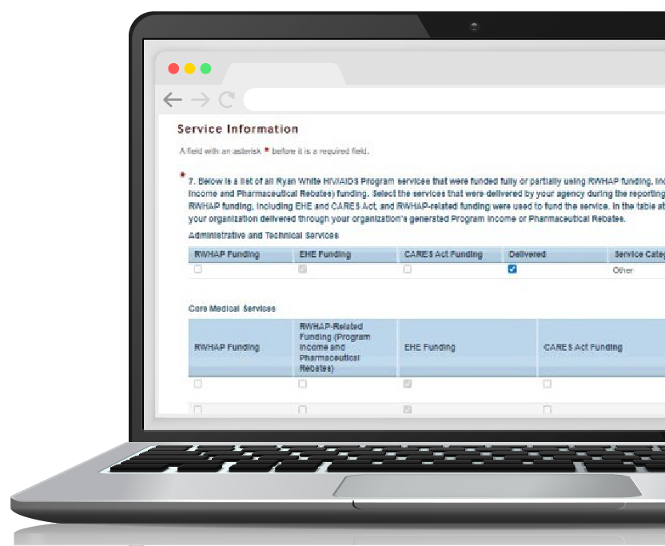
this is something that could all the time
Ryan White HIV/AIDS Program Services Report (RSR)

Instruction Manual 2022
Release Date: December XX, 2022
Public Burden Statement: An agency may not conduct or sponsor, and a person is not required to respond to, a collection of information unless it displays a currently valid OMB control number. The OMB control number for this project is 0906-0039, and the expiration date is 12/31/2024. Public reporting burden for this collection of information is estimated to average 51 hours per response, including the time for reviewing instructions, searching existing data sources, and completing and reviewing the collection of information. Send comments regarding this burden estimate or any other aspect of this collection of information, including suggestions for reducing this burden, to HRSA Reports Clearance Officer, 5600 Fishers Lane, Room 14N136B, Rockville, Maryland 20857.
HIV/AIDS Bureau
Division of Policy and Data
Health Resources and Services Administration
U.S. Department of Health and Human Services
5600 Fishers Lane, Room 9N164A
Rockville, MD 20857

Icons Used in this Manual
The following icons are used throughout this manual to alert you to important and/or useful information.
The Note icon highlights information you should know when completing this section.
The Tip icon points out recommendations and suggestions that can make it easier to complete this section.
The Question Mark icon indicates common questions and their answers.
All new text in the document is indicated with a gray highlight.

Table of Contents
Background 1
Ryan White HIV/AIDS Program 1
Recipient and Subrecipient Reporting Requirements 2
Terminology 3
Classification of Organizations 3
Eligible Services Reporting 4
RWHAP Services 5
What’s New for 2022 6
Changes to Reporting 6
System Enhancements 6
Ryan White HIV/AIDS Program Services Report 9
RSR Recipient Report 10
Accessing the RSR Recipient Report 10
Reviewing and Verifying Your Contracts in the GCMS 14
Completing the RSR Recipient Report 15
Frequently Asked Questions About the RSR Recipient Report 26
RSR Provider Report 28
Accessing the RSR Provider Report 28
Completing the RSR Provider Report 33
Frequently Asked Questions About the RSR Provider Report 56
RSR Client-Level Data Report 60
Checking the Client-level Data XML File 60
Client-level Data Elements 61
Frequently Asked Questions About the Client-Level Data 84
Appendix A. Required Client-Level Data Elements for RWHAP Services 87
Appendix B. Administrative and Technical Services Definitions 89
Glossary 91

Background

Ryan White HIV/AIDS Program
The Ryan White HIV/AIDS Program (RWHAP), first authorized by the U.S. Congress in 1990, is administered by the U.S. Department of Health and Human Services (HHS), Health Resources and Services Administration’s (HRSA) HIV/AIDS Bureau (HAB). This is the largest federal program focused on HIV. The RWHAP funds HIV care and treatment services for low-income people with HIV. Many people who receive services through the RWHAP are uninsured or underserved. RWHAP funds are provided to cities, states, and community-based groups to provide HIV medical care, treatment, and support services for people with HIV; improve health outcomes; and reduce the transmission of HIV.
More than half of people with diagnosed HIV in the United States — approximately 561,416 people in 2020 — receive services through the RWHAP. The RWHAP provides a comprehensive system of care and treatment that plays a key role in ending the HIV epidemic in the United States and works to support the four national goals outlined in the HIV National Strategic Plan:
- Prevent new HIV infections
- Improve HIV-related health outcomes of people with HIV
- Reduce HIV-related disparities and health inequities
- Achieve integrated and coordinated efforts that address the HIV epidemic among all partners and stakeholders
The RWHAP has been increasingly successful at achieving improved outcomes along the HIV care continuum. RWHAP Services Report (RSR) client-level data demonstrate annual improvements in viral suppression, from 69.5 percent of clients in medical care achieving viral suppression in 2010 to 89.4 percent in 2020. Continued improvements in viral suppression will help improve quality and length of life for people with HIV and prevent further HIV transmission.
HRSA HAB regularly monitors program performance to demonstrate accountability and impact. It also integrates performance measurement into long-term programmatic plans to ensure its programs support HRSA strategies.

Recipient and Subrecipient Reporting Requirements
Federal regulations explicitly state that grant recipients must monitor and report program performance to ensure they are using their federal grant program funds in accordance with program requirements.
Title 45 CFR § 75.342(a), monitoring and reporting program performance:
The non-Federal entity is responsible for oversight of the operations of the Federal award-supported activities. The non-Federal entity must monitor its activities under Federal awards to assure compliance with applicable Federal requirements and performance expectations are being achieved. Monitoring by the non-Federal entity must cover each program, function, or activity. See also §75.352.
The federal regulations additionally impose subrecipient monitoring requirements. See 45 CFR §75.352(d):
All pass-through entities must: (d) Monitor the activities of the subrecipient as necessary to ensure that the subaward is used for authorized purposes, in compliance with Federal statutes, regulations, and the terms and conditions of the subaward; and that subaward performance goals are achieved.
HRSA HAB has established the following Office of Management and Budget-approved reporting requirements and has imposed them as a condition of award on RWHAP-funded recipients and subrecipients.
If any protected health information is included in the Ryan White HIV/AIDS Program Services Report, such disclosure is permitted by covered entities, without the written authorization of the individual, as a disclosure to a public health authority. See 45 CFR 164.512(b).

Terminology
This section provides an overview of select terms used throughout this manual and the RSR web system that will be helpful for agencies to understand.

Classification of Organizations
Recipient: A recipient is an organization that receives funding directly from HRSA HAB. A recipient must complete a separate RSR Recipient Report for each RWHAP or EHE award that they receive. Recipients may provide services themselves or allocate funding to other organizations to provide services.
Provider: A provider is any organization that provides services including direct services to clients and/or administrative and technical services. Each provider must complete an RSR Provider Report and upload a properly formatted client-level data file (if they provide services to clients). A provider may be a recipient, a subrecipient, and/or a second-level provider.
Subrecipient: A subrecipient (see Figure 1) is an organization that receives funding directly from a recipient to provide services.
Second-level Provider: A second-level provider (see Figure 2) is an organization that receives funding through a subrecipient to provide services. Occasionally, recipients will use an administrative agent to award and/or monitor the use of their funds. In this situation, the administrative agent (or fiscal intermediary provider) is the recipient’s subrecipient. When this subrecipient enters into a contract with another provider to use the recipient’s funds to deliver services, that provider is considered a second-level provider to the recipient.
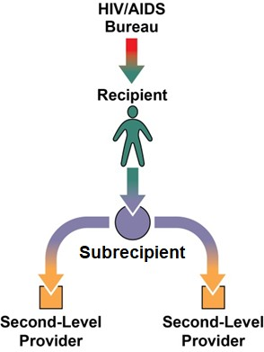
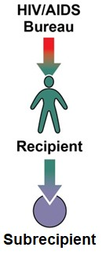
Figure 1. Subrecipient Figure 2. Second-level Provider

Eligible Services Reporting
All Ryan White HIV/AIDS Program (RWHAP) agencies are required to complete Eligible Services reporting as part of the 2022 RSR. Previously, providers used Eligible Scope reporting to determine which clients would be included in the RSR. Under Eligible Scope, providers only reported data on clients who were RWHAP-eligible and received a service for which the provider received RWHAP funding. Under the new Eligible Services Reporting requirement, providers will be required to also include services funded through RWHAP-related funding, which includes program income and pharmaceutical rebates.
When determining whether to report a client, providers should consider two questions:
- Did this client receive at least one service during the reporting period that my organization was funded to provide with RWHAP funding, RWHAP-related funding, and/or EHE Initiative funding (regardless of final payor)?
- Is this client eligible to receive funded services?
If the answer is “yes” to both questions, then the client should be reported on the 2022 RSR. Eligibility requirements are typically set at the recipient level and differ based on the type of funding received to provide services. For RWHAP and RWHAP-related funding, contact your recipient(s) to determine your site’s eligibility requirements.
For EHE Initiative funding, all clients with HIV are eligible to receive EHE Initiative-funded services. Therefore, agencies that receive EHE Initiative funding should report all clients with HIV that receive a service the agency is funded to provide with either RWHAP, RWHAP-related, or EHE Initiative funding, regardless of the final payor.
For further clarification on Eligible Services Reporting and determining which clients to report in your RSR client-level data, please see RSR In Focus: Understanding Eligible Services Reporting.
How do I determine which clients are eligible to receive funded services?
Eligibility requirements differ based on the type of funding the provider receives to provide services. For RWHAP and RWHAP-related fund, eligibility requirements are typically set at the recipient level and are usually based on client income and location. Contact your RWHAP recipient(s) to determine your site’s eligibility requirements for all funding provided by your recipient(s). Additionally, providers that generate their own RWHAP-related funding (program income or pharmaceutical rebates) set their own requirements for those funds.
For EHE Initiative funding, all clients with HIV are considered eligible to receive EHE Initiative-funded services. Therefore, providers that receive EHE Initiative funding to provide services should report all clients with HIV that receive a service for which the provider received RWHAP, RWHAP-related, or EHE Iniative funding to provide.
How do I know if I should report a client in my client-level data?
You should report a client if they are eligible to receive funded services and they received a service that your organization was funded to provide with either RWHAP, RWHAP-related, or EHE Initiative funding.
Should I report client-level data from Housing Opportunities for Persons with AIDS (HOPWA) clients?
HOPWA clients should only be included in the RSR if they meet the requirements described in Eligible Services Reporting. If the client is considered a HOPWA-only client, please do not report those individuals on the RSR. For further information on the HOPWA program, visit the HUD Exchange website.

RWHAP Services
Funded services are divided into three groups:
- Administrative and technical services
- Core medical services
- Support services
Definitions for administrative and technical service categories can be found in Appendix B of this manual. RWHAP core medical and support service categories are listed and explained in Policy Clarification Notice (PCN) #16-02 "Eligible Individuals and Allowable Uses of Funds."
If you have any questions or need assistance with service category definitions, please contact Ryan White Data Support at 1-888-640-9356 or via email at RyanWhiteDataSupport@wrma.com for assistance.
For agencies that received EHE Initiative funds
The “EHE” service category includes those services that are funded through EHE Initiative funding but do not meet the definition of one of the existing RWHAP service categories as outlined in PCN #16-02.

EHE Initiative funding dedicated to services that do meet the definition of one of the RWHAP core medical or support service categories should be reported under that specific service category.

What’s New for 2022

Changes to Reporting

Provider Profile
Users now have the ability to update certain organization details at any point throughout the year using the new Provider Profile. Organizations that use the EHBs Service Provider login portal can find the Provider Profile after logging in with their user account. Providers can update the details in the Provider Profile as needed and synchronize any changes with their RSR Provider Report. The information included in the Provider Profile includes the organization address, EIN, UEI, organization contacts, and Provider Profile Information.

‘New Client’ Data Elements
Two data elements were added to the client-level data for the 2020 RSR and have been reported by all providers since: ‘New Client’ and ‘Received Services in the Previous Year.’ Moving forward beginning with the 2022 RSR, these two data elements will only be required for providers that receive EHE Initiative funding.
The merge logic for these two data elements has also been updated. For additional information on how RSR data are merged in the report, please see the RSR Merge Rules on the TargetHIV website.

System Enhancements

Provider Report Action History
The Action History section of the RSR Provider Report presents details of the various submission steps that the report goes through including when a Provider Report has been accepted by a recipient. This section will now display the grant number of any recipient that accepts the Provider Report, allowing agencies to easily discern which grant(s)/recipient(s) must accept the report before it will advance to “Submitted” status.
Figure 3. RSR Provider Report: Screenshot of the Action History Section
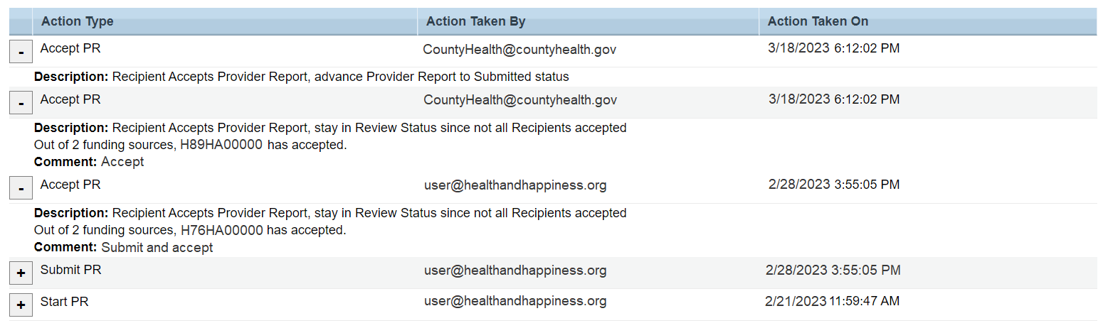

Linking Service Delivery Sites
Agencies are now able to link service delivery sites to multiple providers. When entering a service delivery site, users will now receive a system prompt when the site name and/or address matches an existing service delivery site in the system. This prompt will display existing site name and address combinations. If a user chooses an existing combination, the existing site record will be associated with the Provider Report. Alternatively, users can enter a new site name and address combination to create a new site record.

Prior Year Data in Upload Completeness Report
The RSR Upload Completeness Report (UCR) will now display data from the prior year’s submission (including counts and percentages) in addition to the current year data. Footnotes will be used to describe any data anomalies or changes in measures between current and prior years. The UCR will continue to be exportable into the currently available formats. For more information on the UCR, check out RSR In Focus: How to Use the RSR Upload Completeness Report or the RSR Upload Completeness Report Training Module.
Figure 4. Screenshot of RSR Upload Completeness Report
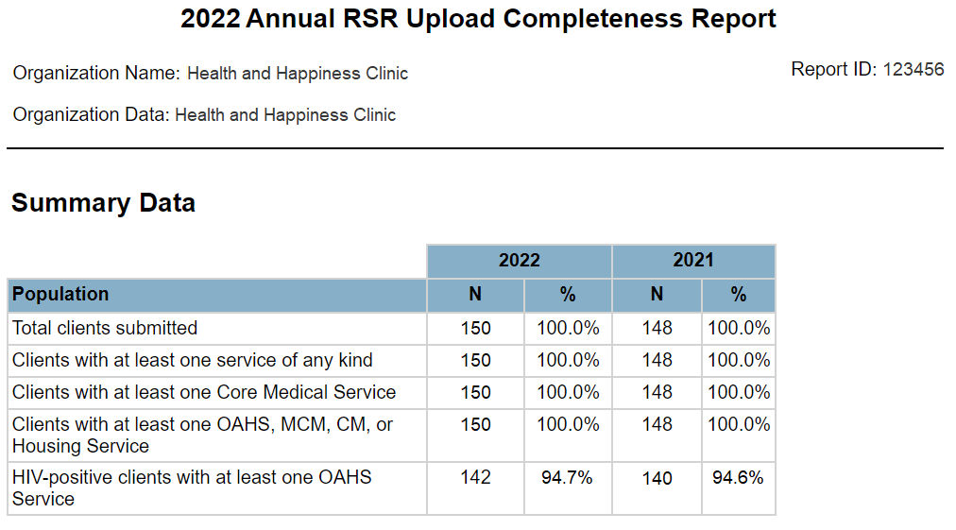

Ryan White HIV/AIDS Program Services Report
The RWHAP Services Report (RSR) is an annual data report completed by RWHAP recipients and providers. This report provides data on the characteristics of the funded recipients and their providers, clients served, and services delivered. The RSR comprises three components: the Recipient Report, the Provider Report, and the client-level data (CLD).
The RSR Recipient Report is completed by recipients who must complete a separate RSR Recipient Report for each RWHAP or EHE award that they receive.
All providers (including providers of direct client services and/or administrative and technical services) must complete a single RSR Provider Report. Providers of direct client services must upload a properly formatted CLD file as part of their Provider Report submission.
For further instructions on completing each part of the RSR, see the sections below:
- RSR Recipient Report
- RSR Provider Report
- Client-level Data File
If you have any questions or are unsure what part(s) of the RSR your organization must complete, please contact Ryan White Data Support at 1-888-640-9356 or via email at RyanWhiteDataSupport@wrma.com for assistance.

RSR Recipient Report
All recipients must submit an RSR Recipient Report for each RWHAP or EHE Initiative award received from HRSA HAB. For example:
- An agency with a RWHAP Part A grant will complete one RSR Recipient Report.
- An agency with an EHE Initiative award and a RWHAP Part A grant will complete two Recipient Reports — one for its EHE Initiative award and one for its RWHAP Part A grant.
- An agency with both a RWHAP Part C and a RWHAP Part D grant will complete two Recipient Reports — one for its RWHAP Part C grant and one for its RWHAP Part D grant.
The RSR Recipient Report is divided into two sections: General Information and Program Information. The first section, General Information, contains basic information about the recipient organization such as the mailing address and contact information.
The second section, Program Information, is a list of all the organizations that were funded to provide services during the reporting period including any subrecipients, second-level providers, and the recipient themselves (if they provide services using their award funding). This list is populated from the contracts entered by the recipient in the Grantee Contract Management System (GCMS). All providers (including the recipient if they provide services) must have a contract in the GCMS and be listed in the Program Information section in order to be tied to the recipient’s award and have an RSR Provider Report to submit.

Accessing the RSR Recipient Report
To access the RSR Recipient Report, follow these steps.
step one: Navigate to the HRSA Electronic Handbooks (EHBs). On the Select Role page, choose the “Applicant/Grantee” box at the top-left side of the screen (see Figure 5). On the next page, login using your username and password.
Figure 5. HRSA Electronic Handbooks: Screenshot of the EHBs Select Role Page
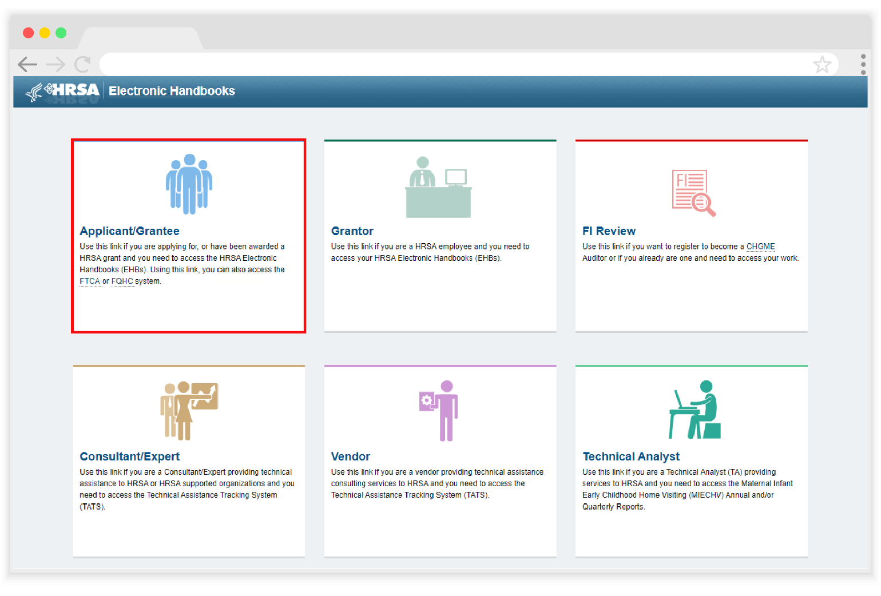
Step Two: From the EHBs homepage, hover your cursor over the “Grants” tab, on the top-left side of the screen (see Figure 6).
If you need help navigating the EHBs to find your RSR, call the EHBs Customer Support Center at 1-877-464-4772.
Figure 6. HRSA Electronic Handbooks: Screenshot of the Recipient EHBs Home Page
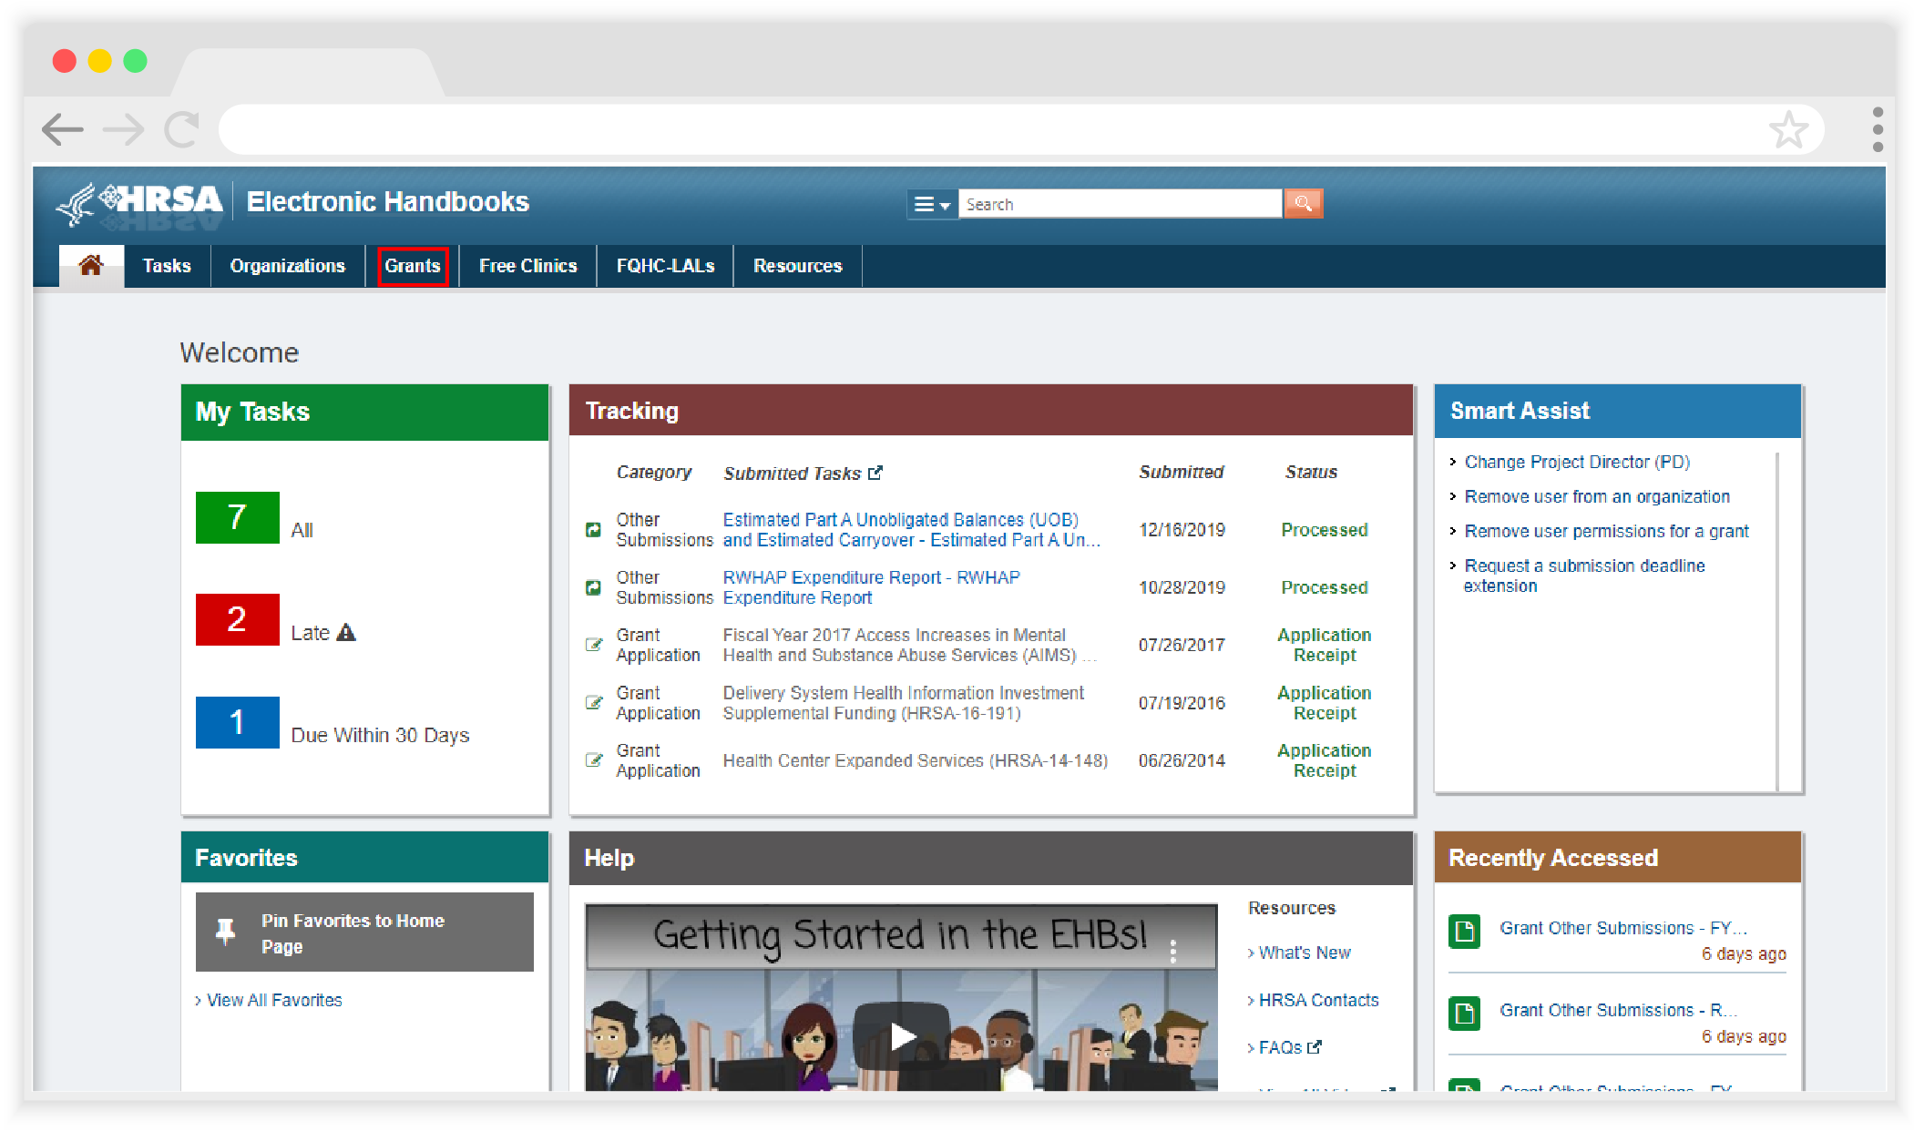
STEP Three: From the resulting drop-down menu, under the “Submissions” header, select “Work on Performance Report” (see Figure 7).
Figure 7. HRSA Electronic Handbooks: Screenshot of the Grants Drop-Down Menu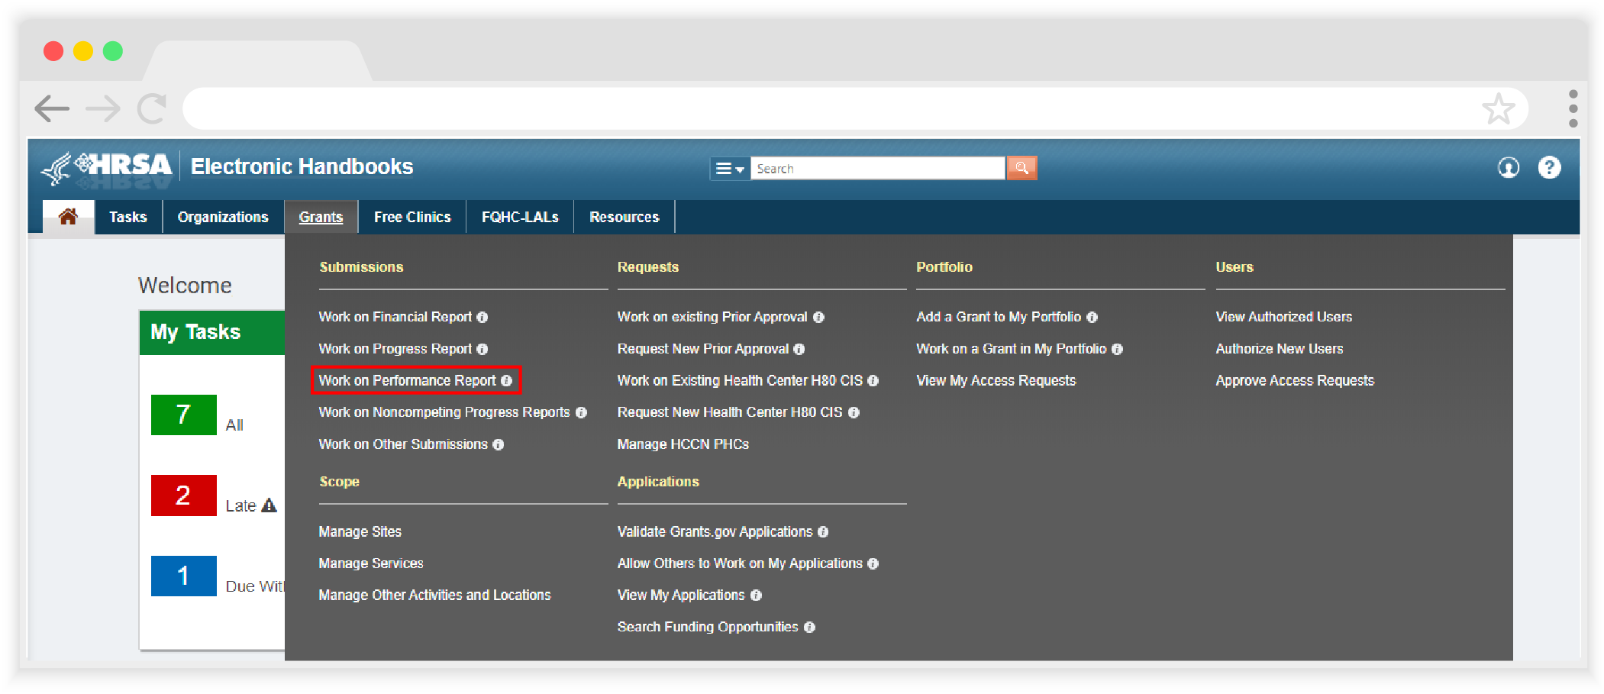

STEP Four: On the bottom of the next page, the Submissions - All page, under “Submission Name,” locate your 2022 RSR. Select “Start” or “Edit” under the “Options” header to access the RSR system (see Figure 8). A new window will appear.
Figure 8. HRSA Electronic Handbooks: Screenshot of the Submissions-All Page
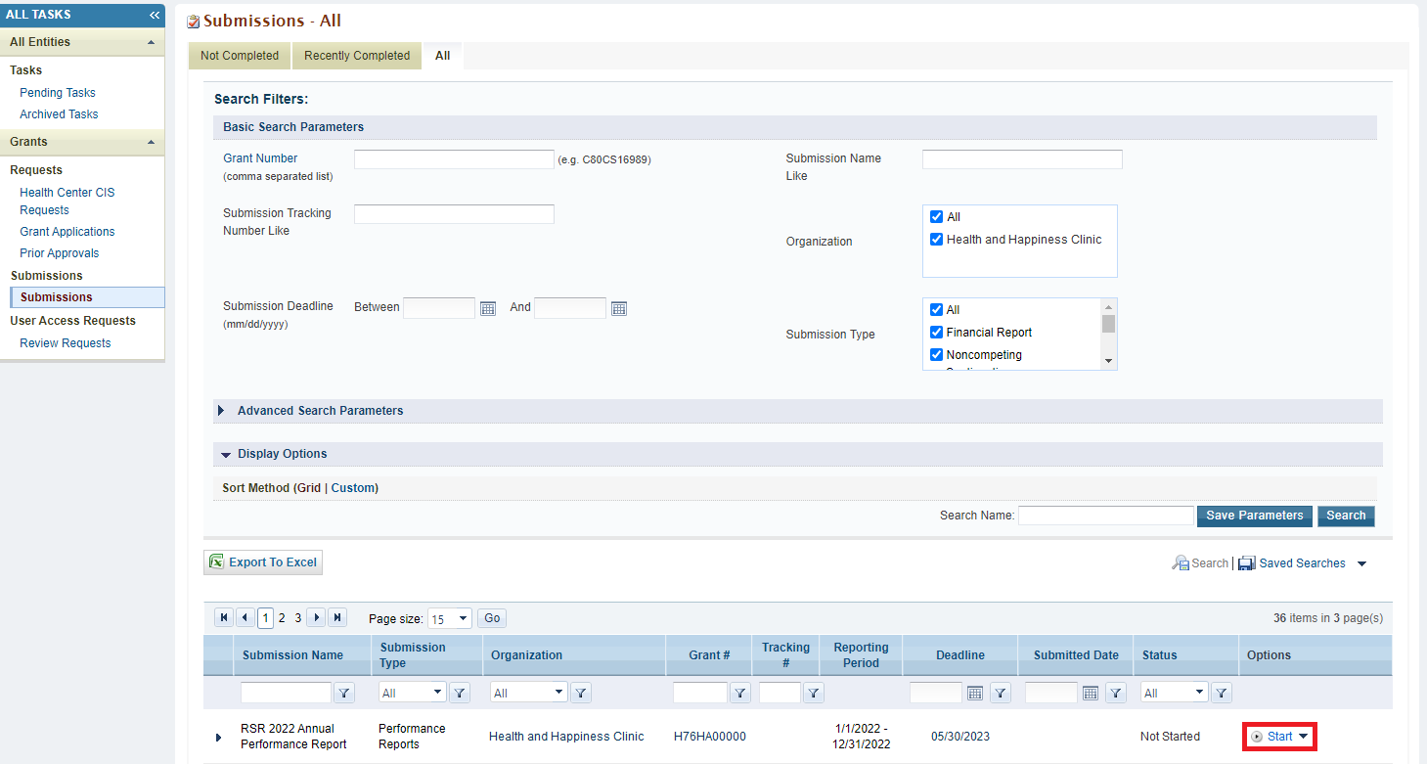
STEP Five: You are now in the RSR Recipient Report Inbox (see Figure 9). From here, you can access your report as well as the contracts in the GCMS. To access the GCMS, select “Search Contracts” in the Navigation panel on the left side of the screen. To access your RSR Recipient Report, select the envelope icon under the “Action” Column. If the report has not been started yet, the icon will read “Create.” Once the report has been started, it will instead read “Open.”
Figure 9. HRSA Electronice Handbooks: Screenshot of the RSR Recipient Report Inbox
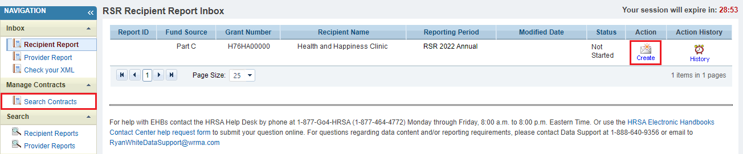

Reviewing and Verifying Your Contracts in the GCMS
All RWHAP and EHE contract information is stored in the Grantee Contract Management System (GCMS). Contract information from the GCMS is pulled directly into and will populate the RSR Recipient Report. All organizations that are funded to provide services with your grant (including your own recipient organization if you provide services) must have a contract in the GCMS in order to be associated with your award and have an RSR Provider Report to submit.
Contracts are typically entered into the GCMS by recipients as part of their PTR/Allocations Report submission. For the RSR Recipient Report, recipients must review their contracts in the GCMS to make sure they are accurate and up to date, paying particular attention to the funded service categories and making sure each provider has a contract for the reporting period. Recipients that utilize RWHAP-related funding (including program income and pharmaceutical rebates) must make sure that RWHAP-related funded services are included in their GCMS contracts as well. Contracts listed in the GCMS should match the actual agreements recipients have in place with their subrecipients. For the purpose of the RSR, contracts include formal contracts, memoranda of understanding, or other agreements.
For in-depth instructions on managing contracts in the GCMS, please see the 2022 GCMS Instruction Manual and the 2022 Completing the GCMS Webinar available on the TargetHIV website.
Agencies that are funded to provide services using EHE Initiative carryover funding must report on those services in the RSR. Please contact Ryan White Data Support at 1-888-640-9356 or via email at RyanWhiteDataSupport@wrma.com for assistance setting up your contracts for providers receiving EHE Initiative carryover funding.
If you need help managing your contracts or locating/adding a subrecipient to the web system, contact Ryan White Data Support at 1-888-640-9356 or via email at RyanWhiteDataSupport@wrma.com.

Completing the RSR Recipient Report
Once you have reviewed your contracts in the GCMS and made any necessary updates, you are ready to begin working on the RSR Recipient Report. To access the RSR Recipient Report Inbox, select “Recipient Report” under the “Inbox” header in the Navigation panel on the left side of the screen. Access your report by selecting the envelope icon under the “Action” column (see Figure 9). Opening your report will automatically direct you to the General Information section of the report.
You can navigate through each section of the Recipient Report and all report actions using the Navigation panel on the left side of the screen (see Figure 10). Complete each section of the report before validating and certifying it. Once the Recipient Report has been certified, it will advance to “Submitted” status only when all associated RSR Provider Reports have been submitted and accepted by the recipient.
Figure 10. RSR Recipient Report: Screenshot of the Navigation Panel
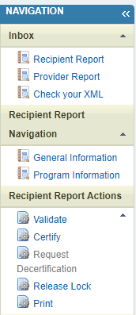

General Information
The General Information section (see Figure 11) of the RSR Recipient contains multiple fields prepopulated from the HRSA EHBs with basic details about your organization. Review each of the fields as follows below for accuracy and make any updates as needed. Ensure that all required fields have a response. If you make any changes to the information on this page, select the “Save” at the bottom-right of the screen to save your edits.

- Official Mailing Address
- Street
- City
- State
- ZIP Code
- Organization Identification
- EIN
- UEI
If you need help locating your organization’s UEI, contact Ryan White Data Support for assistance by phone at 1-888-640-9356 or via email at RyanWhiteDataSupport@wrma.com.
- Contact information of person responsible for this submission: The person listed here will be the primary contact for RSR-related issues.
- Name
- Title
- Phone and extension (if applicable)
- Fax
- Email
- Did you receive a Minority AIDS Initiative designation for your Part C or D grant (documented on your Notice of Award) at any time during the reporting period? This question is for RWHAP Parts C and D recipients only. Indicate whether your agency received a Minority AIDS Initiative (MAI) designation during the reporting period. If your agency did receive MAI funding, specify the most recent percentage designation for the reporting period.
No
Yes
If yes, please specify the most recent percentage designation for the reporting period
Figure 11. RSR Recipient Report: Screenshot of the General Information Section
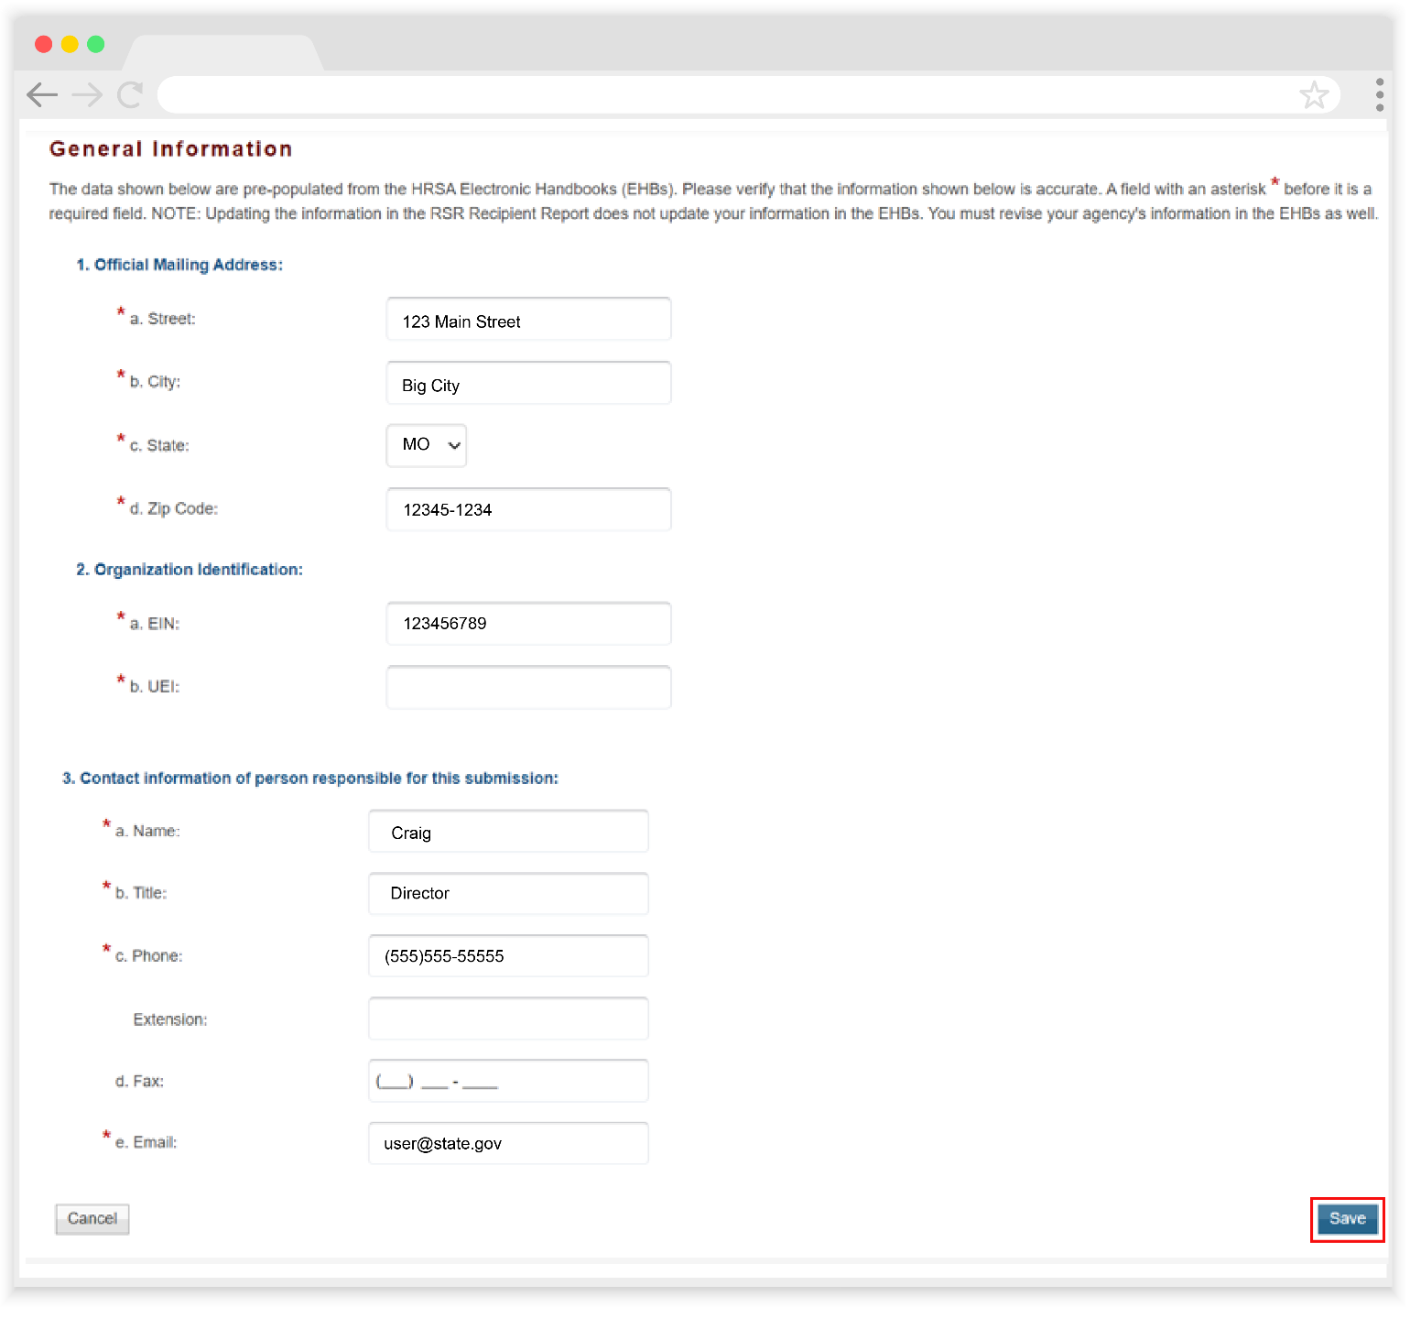

Program Information
To access the Program Information section, select “Program Information” under the “Recipient Report Navigation” header in the Navigation panel on the left side of the screen. This section shows every organization funded to provide services with your grant during the reporting period as listed in your contracts in the GCMS. Review the list of your service providers that were active during the reporting period.
Figure 12. RSR Recipient Report: Screenshot of the Program Information Section
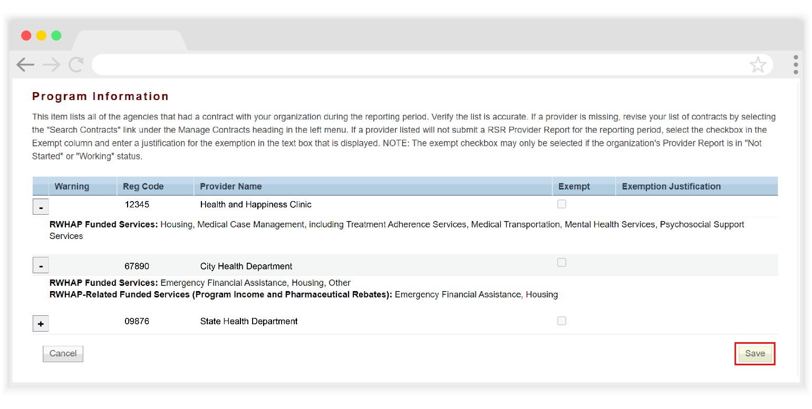
Select the “+/- (Expand/Collapse)” icon to view the funded services for each organization (see Figure 12). The list should display all the services that each agency was funded to provide with your grant funding. Confirm the list of funded services for each organization is accurate and complete.
If you need to make any updates to the information in this section, you must make those changes to the associated contract(s) in the GCMS (see Reviewing and Verifying Your Contracts in the GCMS). If you make any updates to your contracts in the GCMS after starting your RSR Recipient Report, you must synchronize those changes to fully integrate them into your report.

Figure 13. RSR Recipient Report: Screenshot of the Program Information Section with Synchronization Warning
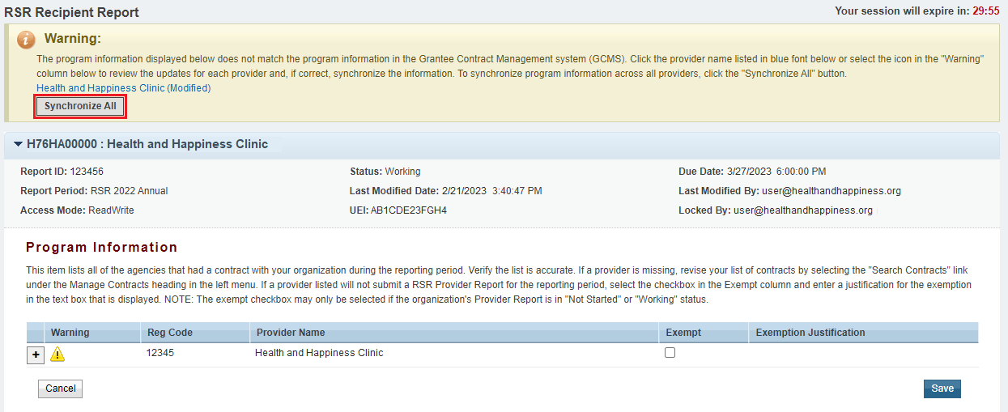
When you have pending contact changes to synchronize, you will see a yellow warning banner at the top of the page (see Figure 13). Select the “Synchronize All” button to synchronize all changes at once or select each agency’s name in blue to synchronize contracts individually. On the next page (see Figure 14), review the list of changes to your contract(s) and select the “Synchronize” button to accept the changes and incorporate them into your RSR Recipient Report.

Figure 14. RSR Recipient Report: Screenshot of the Synchronization Confirmation Page
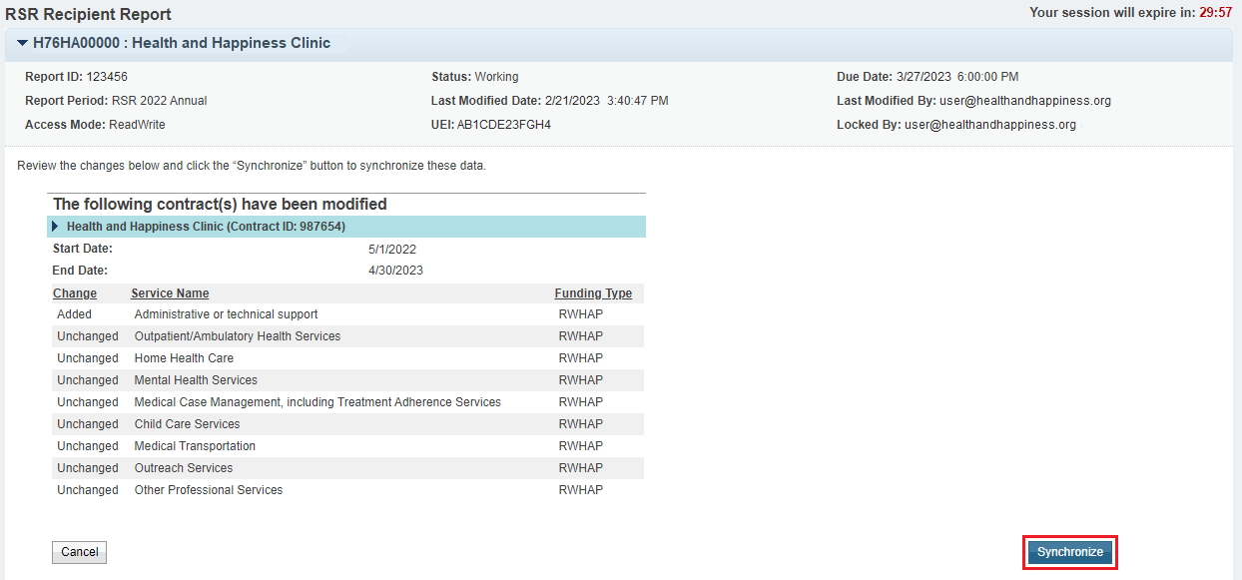

Provider Exemptions
If you need to exempt a provider from reporting, check the box in the “Exempt” column, and enter a brief explanation for the exemption. If you make any edits to this section, click “Save” at the bottom of the page to save your changes before navigating away.
Recipients may exempt providers from completing a separate Provider Report if they meet one or more certain criteria:
- They submit only vouchers or invoices for payment (e.g., a taxicab company that only provides transportation services)
- They do not see clients on a regular and sustained basis (e.g., on an emergency basis only)
- They offer services to clients on a “fee-for-service” basis
- They provide only laboratory services to clients
- They received less than $10,000 in funding during the reporting period (January 1–December 31)
- They see a small number (1–25 clients) of RWHAP clients
- They did not provide services during the reporting period (January 1–December 31)
- They are no longer funded by the recipient
- They are no longer in business
If a provider has multiple recipients, they all must mark the provider as “Exempt” for the provider to be considered exempt from reporting.
Recipients should contact their project officer for questions about exemption requirements.
Exempting a provider though does not exempt the recipient from collecting and reporting that provider’s data on their behalf. Recipients must ensure that exempted providers’ data are still reported to HRSA HAB. If a provider meets one or more of the criteria above and a recipient is considering exempting them, they have the following options:
- Do not exempt the provider and complete their Provider Report on their behalf: Recipients may complete the Provider Report for their providers including uploading their client-level data. In this case, recipients do not select the “Exempt” check box and simply complete the Provider Report using the instructions in Completing the RSR Provider Report.
- Exempt the provider and include the exempted provider’s data with their own RSR data: This option makes the most sense when there are multiple exempt providers or when an exempted provider’s data are not easily separated. Recipients can include all exempted providers’ data in a single RSR Provider Report of their own. In this case, all of the provider’s recipients must mark the provider as exempt.
When exempting a second-level provider, the second-level provider’s data must be included in the associated subrecipient’s (i.e. fiscal intermediary provider) Provider Report. In this case, the recipient will select the “Exempt” checkbox for the second-level provider.
Recipients may also mark organizations providing only administrative and technical services as exempt. In this case, there are no client-level data to report but the recipient must still submit the provider’s report using the instructions below.
For assistance setting up your contracts to support reporting for exempted providers, contact Ryan White Data Support by phone at 1-888-640-9356 or via email at RyanWhiteDataSupport@wrma.com.
When a recipient exempts a provider, the exempted provider’s RSR Provider Report must still be submitted. While the majority of the report may be left blank, recipients must still complete the Service Delivery Sites section of the Provider Report (see Service Delivery Sites for further instructions) and confirm that the information there is accurate and up to date.
Certain organizations may not be given an exemption. Recipients are not able to exempt themselves or another recipient-provider. Additionally, providers that are both a subrecipient and a second-level provider may not be given an exemption.
Providers that only provide laboratory services and no other services may be exempt from reporting. However, HRSA HAB requires providers that offer laboratory services among other services to report laboratory service data under Outpatient/Ambulatory Health Services, even if a client only received the laboratory services and no other service.
What if a provider that receives funding from multiple RWHAP Parts is given an exemption from reporting by one recipient but not another?
Providers must be exempted from reporting by all their recipients. If your provider is funded by other recipients, you will need to coordinate with those other entities to ensure that all are in agreement regarding the exemption. If one or more recipients do not agree to exempt the provider, then the provider will still need to complete the RSR Provider Report.
I have a provider that has been exempted by all recipients that fund the agency. Why is there a report in “Not Started” status for the provider?
If a provider has been exempted by all recipients, there will still be an exempt Provider Report that must be submitted and accepted by all recipients. While the majority of the report may be left blank, the Service Delivery Sites section of the report should still be reviewed and updated.
A provider is funded for Outpatient/Ambulatory Health Services and provides laboratory services. Are they exempt from reporting the laboratory services?
Laboratory services are considered an activity of the Outpatient /Ambulatory Health Services category. Therefore, the agency would report laboratory services data under Outpatient/Ambulatory Health Services, even if a client only received the laboratory services, and no other Outpatient/Ambulatory Health Services activity was included.

Validating the Recipient Report
Once you have completed both sections of the RSR Recipient Report, the next step is to validate the report. To do that, select “Validate” under the “Recipient Report Actions” header in the Navigation panel on the left side of the screen.
The system will display a message letting you know that the validation request is processing. Wait a few minutes and then refresh the page by selecting “Validate” again. Once completed, the system will display either a green “Congratulations” message or a table of validation results (see Figure 15). If you receive the “Congratulations” message, then your report does not have any validation issues to address and you can advance to certifying your report.
Alternatively, validation results are sorted into three categories as detailed below:
- Errors must be corrected. You are not able to certify your report with an error.
- Warnings should be corrected whenever possible but if you are unable to, you may still certify your report with a warning by adding a comment to your validation results that explains your agency’s situation as it relates to the validation message. To add a comment to a warning:
Select “Add Comment” under the “Actions” column to the right of the warning validation.
A new window will appear for you to enter your comment.
When finished, select “Save” at the bottom of the text box.
- Alerts should also be corrected whenever possible but if you are unable to, then you may still certify your report with an alert without taking any further action. However, it is highly recommended to correct all validation issues before certifying whenever possible.
If you make any changes to your report after validating, you must validate your report again before you are able to certify.
Figure 15. RSR Recipient Report: Screenshot of the Validation Results Page
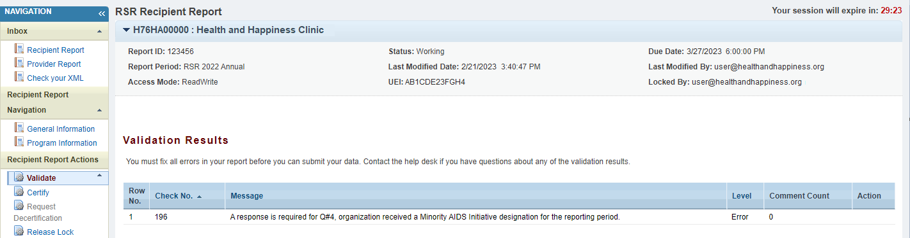

Certifying the Recipient Report
After you have validated your report and responded to any validation issues, the next step is to certify your report. In the Navigation panel on the left side of the screen, select “Certify” under the “Recipient Report Actions” header. On the next page (see Figure 16):
- Enter a comment in the text box with any meaningful feedback you have about the submission process.
- Check the box under the comment box indicating that you certify that the data in the report are accurate and complete.
- Select the “Certify Report” button at the bottom of the page.
Your RSR Recipient Report will then advance to “Certified” status. Your report must be in “Submitted” status by the final deadline. To advance your report to “Submitted” status, you must accept all RSR Provider Reports associated with your grant. For instructions on accepting a Provider Report, please see Accepting the Provider Report.
If you need to make edits to your Recipient Report after it has been certified, reach out to Ryan White Data Support for assistance at 1-888-640-9356 or via email at RyanWhiteDataSupport@wrma.com.
Make sure that your RSR Recipient Report has been certified before the Recipient Report deadline. Your providers will not be able to submit their RSR Provider Reports if your Recipient Report has not been certified.
Figure 16. RSR Recipient Report: Screenshot of the Certify Report Page
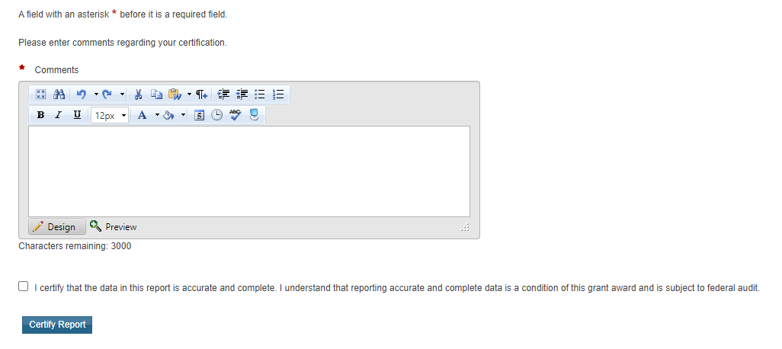

Frequently Asked Questions About the RSR Recipient Report
Are recipients able to access previous years’ submissions to review the data submitted for the RSR Recipient Report?
Recipients can review previously submitted Recipient Reports in the RSR web system at any time. To access these reports, search for the applicable year’s report in the EHBs. If you need further assistance searching for these reports, contact Ryan White Data Support.
We are a RWHAP Part C and D recipient; we are also a RWHAP Part A subrecipient. We do not have any subrecipients and use our funding to provide services to clients. What components of the RSR do we have to complete?
You must submit two RSR Recipient Reports, one for your RWHAP Part C grant and one for your RWHAP Part D grant. You also must complete one RSR Provider Report that includes data on all the services your agency is funded to deliver. As part of your Provider Report, you must submit client-level data that includes one record for each eligible client that received a service during the reporting period that you were funded to provide.
Are agenicies that are only funded by RWHAP Part B Minorty AIDS Iniative dollars required to submit the RSR?
A Part B Minority AIDS Iniative (MAI) funded subrecipient may report on the RSR if the service they are providing fits within a service category definiton listed PCN 16-02. If the service does not meet the criteria you should not report the RWHAP Part B MAI service on the RSR.
Is information for RWHAP-related funded (program income or pharmaceutical rebates) services required in my Recipient Report?
Yes. You should include your organization’s RWHAP-related funded services (including program income and pharmaceutical rebates) in your RWHAP contracts in the GCMS and your Recipient Report. Do not include funding amounts for RWHAP-related funded services in your contracts.
I contract with one of my subrecipients to provide AIDS Drug Assistance Program (ADAP) services only. Will this subrecipient submit an RSR?
No. This subrecipient is not required to submit an RSR. ADAP services are reported on in the ADAP Data Report (ADR).
Our organization contributes some of our RWHAP grant to the state’s RWHAP Part B ADAP. Should I include a contract with the state (or its RWHAP ADAP contractor) on my contract list?
Yes, a contract should be entered into the GCMS for the respective contract period. However, agencies that are only funded for ADAP services are not required to submit an RSR. Contracts funded only for ADAP services will not populate in your RSR Recipient Report. ADAP funded services are reported on the ADR.
I am a recipient and have a contract with a fiscal intermediary. Do I list second-level provider services in the fiscal intermediary contract?
No. First, create a contract for the fiscal intermediary in the GCMS. On question 5 of the contract, indicate that the subrecipient is a fiscal intermediary. Then, create a separate contract for the second-level provider. Under question 6 in the GCMS, indicate “Yes,” and select the fiscal intermediary that funds the organization. The services that the second-level provider is funded for should be included in the second-level provider’s contract.
The services listed for one of my subrecipients are not correct. Where can I edit the services?
You must make any required updates to the contract in the GCMS. Select “Search Contracts” to enter the GCMS, search and select the associated contract, make any updates as necessary, and synchronize your report. As a reminder, verify contracts before starting the Recipient Report to avoid the need to synchronize the data.
I have already certified my Recipient Report, and I am no longer able to make any changes. What do I need to do?
You are not able to make changes to your Recipient Report while it is in “Certified” status. Contact Ryan White Data Support for assistance making changes to your report after it has been certified at 1-888-640-9356 or RyanWhiteDataSupport@wrma.com.
Do I need to complete a Recipient Report for my EHE Initiative funding?
Yes. Recipients must complete a separate Recipient Report for each grant that they receive from HRSA HAB including RWHAP Parts A, B, B Supplemental, C, and D as well as EHE Initiative awards.

RSR Provider Report
The Provider Report is a collection of basic information about the provider and the services the provider delivered. All agencies that provide services using RWHAP funding, RWHAP-related funding (including program income and pharmaceutical rebates), and/or EHE Initiative funding are required to complete an RSR Provider Report.
Multiply funded providers should include data from all of their funding sources in a single RSR Provider Report.
Unless exempted, all provider agencies are expected to complete their own reports to confirm that their data accurately reflect their program and the quality of care their agency provides.
The RSR Provider Report is divided into sections as shown below and will be explained in further detail in the upcoming parts of this manual:
- General Information: Basic information about the provider organization such as the mailing address, organization contacts, and service delivery sites.
- Program Information: Additional information about the provider as well as questions regarding medication assisted treatment (MAT) for opioid use disorder.
- Service Information: Details the services the provider was funded to provide.
- HC&T Information: Aggregate data on HIV counseling and testing (HC&T) activities.
- Clients by ZIP Code: Aggregate data on the number of clients residing in each ZIP Code.
- Import Client-level Data: Report section where providers upload their client-level data (CLD) file.

Accessing the RSR Provider Report
Providers will access and complete the 2022 RSR Provider Report via the HRSA Electronic Handbooks (EHBs). However, your access to the EHBs will differ depending on how your organization is categorized:
- Recipient-Providers: These are organizations that receive a RWHAP and/or EHE award directly from HRSA HAB. Users from these organizations will access the HRSA EHBs through the Applicant/Grantee portal and locate their 2022 RSR deliverable in their organization’s list of Performance Reports.
- Provider Only Organizations: These are agencies that do not receive a RWHAP or EHE award directly from HRSA HAB but do receive RWHAP, RWHAP-related, or EHE Initiative funding from a recipient to provide services. Users from these organizations will access the HRSA EHBs through the Service Provider portal and enter the RSR system.
The following sections provide detailed instructions for how each type of organization will access the RSR Provider Report.
If you need assistance logging into the EHBs or creating a new user account, contact the EHBs Customer Support Center at 1-877-464-4772.
If you need assistance identifying how your agency should access the HRSA EHBs and the RSR Provider Report, contact Ryan White Data Support at 1-888-640-9356 or via email at RyanWhiteDataSupport@wrma.com.

Recipient-Providers
Recipient-providers will access the HRSA EHBs through the Applicant/Grantee portal. Login using your username and password. Hover over the “Grants” tab at the top of the page and select “Work on Performance Report.” On the next page, the “Submissions-All” page, locate your 2022 RSR deliverable and select “Start” or “Edit” under the “Options” column to the right.
You will now be in the RSR Recipient Report Inbox (for more detailed instructions on getting to this point see Accessing the RSR Recipient Report). To navigate to the RSR Provider Report, select “Provider Report” under the “Inbox” header in the Navigation panel on the left side of the screen (see Figure 17).
The RSR Provider Report Inbox (see Figure 18) will list all RSR Provider Reports associated with the grant number on the RSR deliverable you used to access the RSR system. To open a report, select the envelope icon under the “Action” column of the report you want to access. The first time a report is accessed, the icon will read “Create” and after the report has been started the icon will instead read “Open.”
If you need help navigating the EHBs to find your RSR, call the EHBs Customer Support Center at 1-877-464-4772.
Figure 17. RSR Provider Report: Screenshot of the RSR Recipient Report Inbox
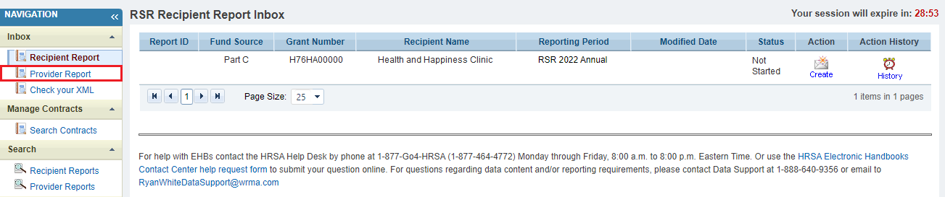
Figure 18. RSR Provider Report: Screenshot of the RSR Provider Report Inbox
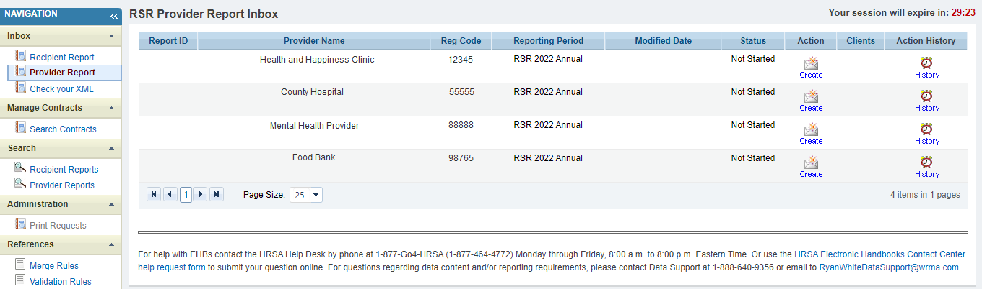

Provider Only Organizations
Organizations that are a provider only and not the recipient of any RWHAP or EHE award, will access the HRSA EHBs through the Service Provider portal. To access the RSR Provider Report, follow these steps:
Step One: Navigate to the HRSA Electronic Handbooks (EHBs). On the Select Role page, choose the “Service Provider” box at the bottom-left side of the screen (see Figure 19). On the next page, login using your username and password.
Figure 19. HRSA Electronic Handbooks: Screenshot of the EHBs Select Role Page
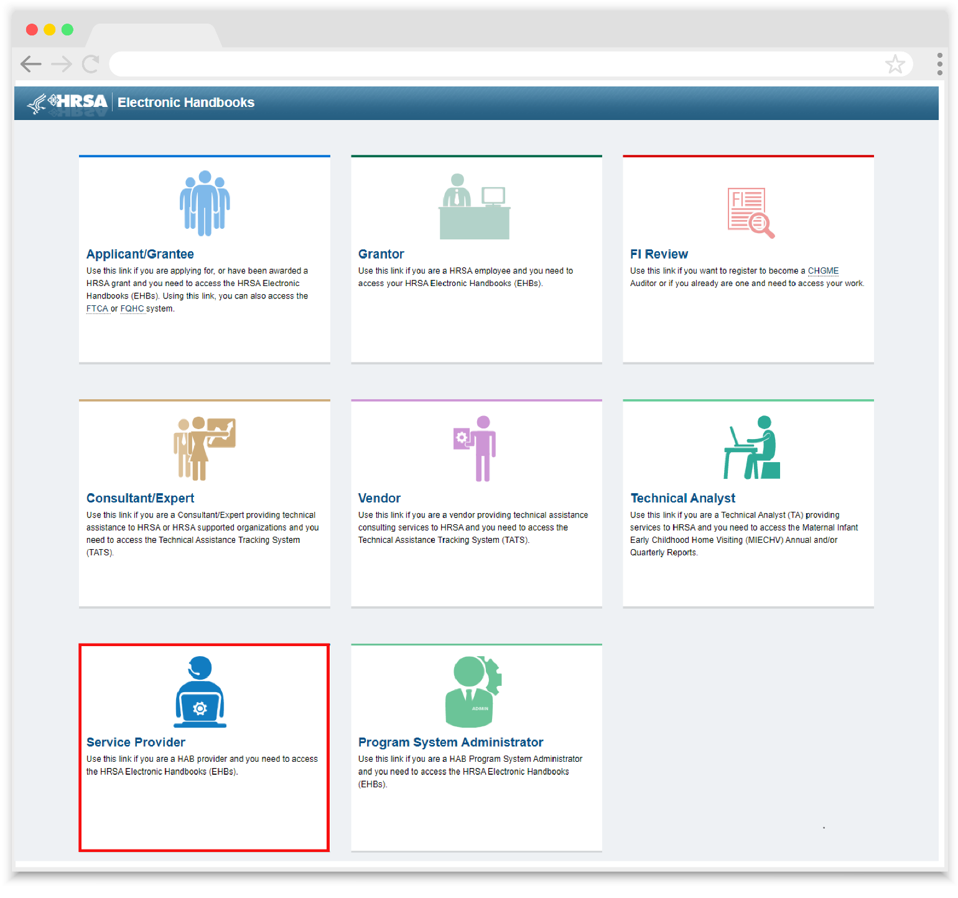
Step Two: Logging in will bring you to the EHBs Home page (see Figure 20). Select the “Organization” tab at the top of the page.
If you need to create a new user account in the HRSA EHBs Service Provider portal, you will need the GUID Code for your agency. The GUID Code is a system-generated identifier unique to your organization that is used to associate a user account with a provider organization. Contact Ryan White Data Support at 1-888-640-9356 or via email at RyanWhiteDataSupport@wrma.com to get your agency’s GUID Code.
Figure 20. HRSA Electronic Handbooks: Screenshot of EHB Service Provider Home Page
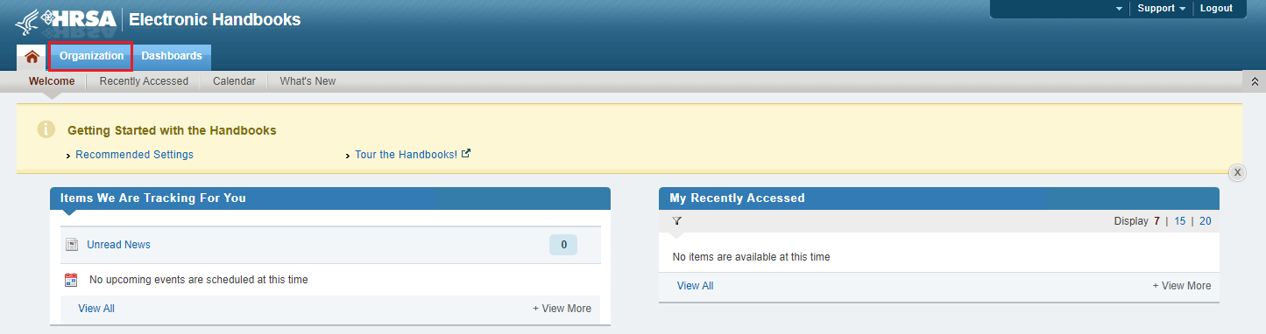
Step Three: The next page, the “My Registered Organizations – List” (see Figure 21), will show all organizations that your user account is registered to. Locate the provider agency for which you would like to access the RSR Provider Report and select the “Organization Folder” under the “Options” column on the far-right.
Figure 21. HRSA Electronic Handbooks: Screenshot of the My Registered Organizations – List Page
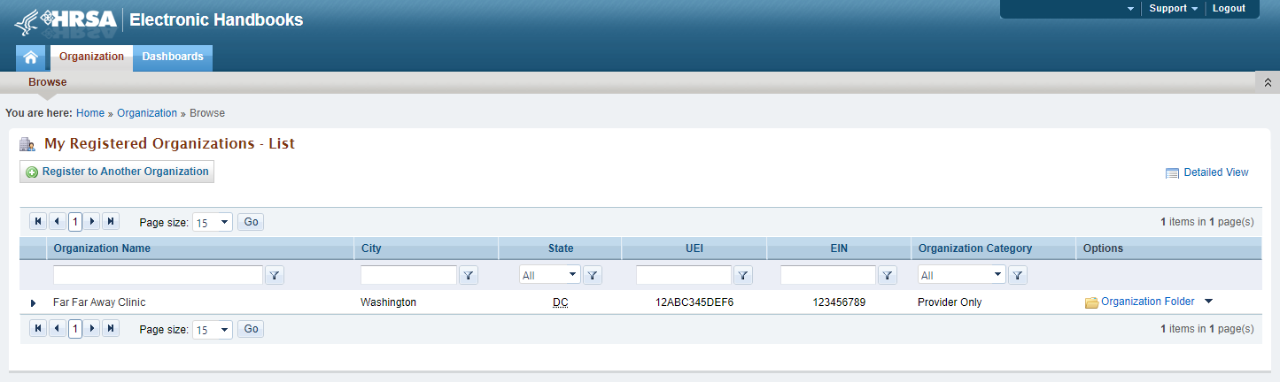
Step Four: Selecting the “Organization Folder” will bring you to the “Organization Home” page (see Figure 22). Select the “Access RSR (includes modules such as Check your XML HIVQM, CDR, and EHE)” link in the center of the page.
Figure 22. HRSA Electronic Handbooks: Screenshot of Organization Home Page
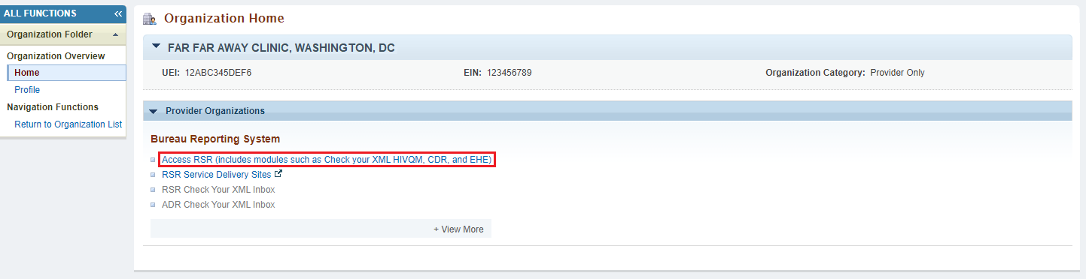
Step Five: You are now in the RSR Provider Report Inbox (see Figure 23). Select the envelope icon in the “Action” column to access your Provider Report.
Figure 23. RSR Provider Report Inbox: Screenshot of RSR Provider Report Inbox
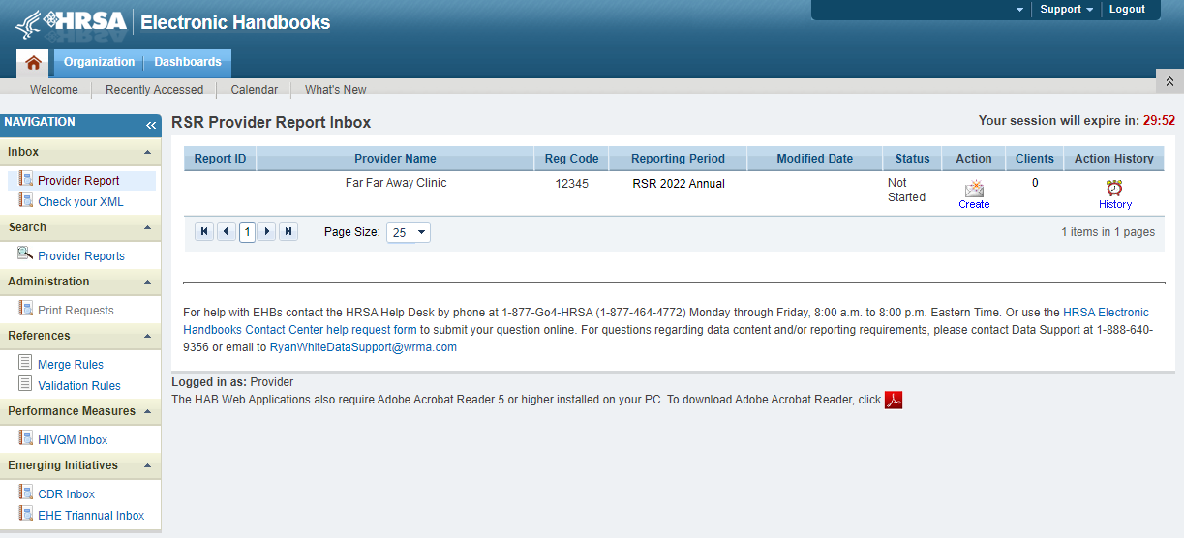

Completing the RSR Provider Report
Opening the Provider Report will take you to the first section of the report, General Information. You can navigate through each section of the Provider Report and all report actions using the Navigation panel on the left side of the screen (see Figure 24). Complete each section of the report before validating and submitting it. Once the Provider Report has been submitted, it must then be accepted by all recipients that fund the provider, after which it will advance to “Submitted” status.
Figure 24. RSR Provider Report: Screenshot of the Navigation Panel
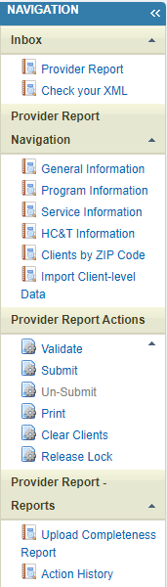

General Information
The General Information section of the RSR Provider Report is populated from your organization’s Provider Profile and Service Delivery Sites in the HRSA EHBs. Review the information here for accuracy and completeness. Any updates to the Organization Details, Organization Contacts, and Provider Profile Information should be made in the Provider Profile in the HRSA EHBs. Providers that utilize the HRSA EHBs Service Provider portal can update their Provider Profile at any time throughout the year. From the Organization Home page (see Figure 25) select the “Profile” link in the Navigation panel on the left side of the screen (see Accessing the RSR Provider Report for detailed instructions on navigating to this page).
Figure 25: HRSA Electronic Handbooks: Screenshot of the Organization Home Page
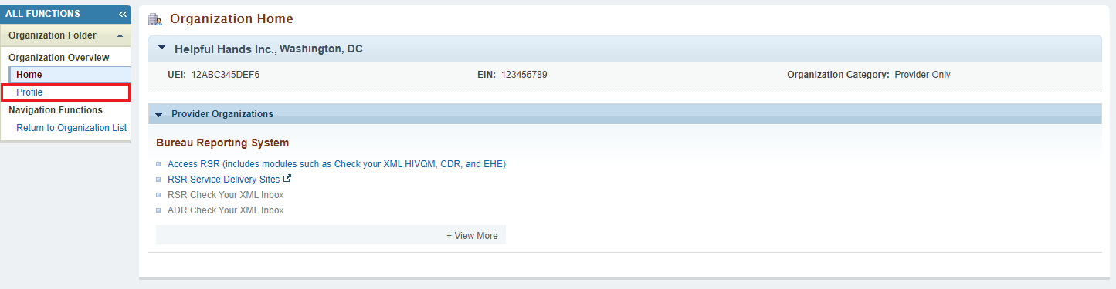
The information that can be updated in the Provider Profile includes all fields in the Organization Details, Organization Contacts, and Provider Profile Information. The Service Delivery Sites are not part of the Provider Profile and should be updated within the Service Delivery Sites section accessible through your HRSA EHBs account (see Service Delivery Sites for more information).
If you make any updates to the Provider Profile after opening your RSR Provider Report, you must synchronize those changes with your Provider Report to fully integrate them into your report. In the General Information section of the report, you will see a yellow warning banner at the top of the page (see Figure 26). Select the “Synchronize” button to synchronize the changes you made to your Provider Profile into your RSR Provider Report.
Figure 26. RSR Provider Report: Screenshot of the General Information Section with Synchronization Warning Banner
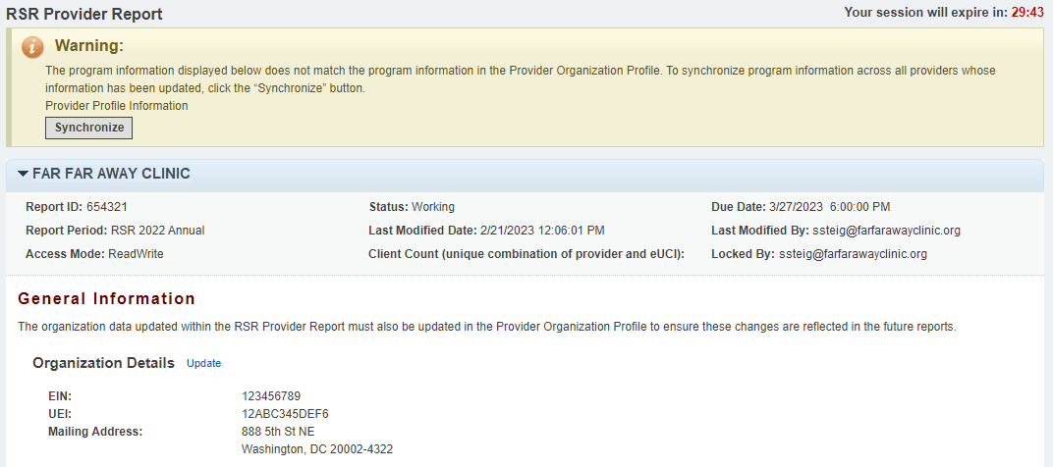
Agencies are still able to update the data in the General Information section directly within the Provider Report (e.g., using the “Update” link in Organization Details to update the mailing address, EIN, and/or UEI). In this case, providers will also see the yellow warning banner at the top of the page. Synchronizing after making changes directly to the report instead of the Provider Profile will revert the data in this section back to the data that are in the Provider Profile.
Recipients filling out this section for any of ther providers should make sure that the information included here is indicative of their provider and not the recipient organization.
If you are a recipient and need to make changes to the General Information section of your own Provider Report or one of your subrecipients’ reports, contact Ryan White Data Support at 1-888-640-9356 or via email at RyanWhiteDataSupport@wrma.com.
Figure 27. RSR Provider Report: Screenshot of the General Information Section
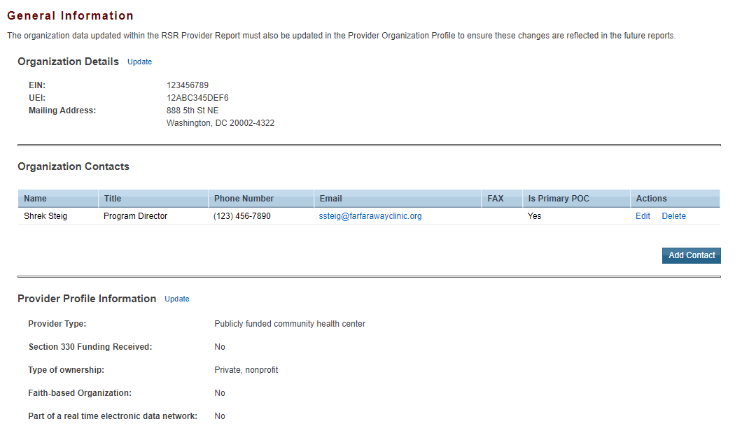
The following fields are included in the General Information section (see Figure 27) of the Provider Report:

Organization Details
- EIN: The provider’s Employer Identification Number.
- UEI: The provider’s Unique Entity Identifier (UEI) is a 12-character alphanumeric ID assigned to an entity by SAM.gov.
- Mailing Address: The provider’s main mailing address.
If you need assistance with your agency’s UEI, contact Ryan White Data Support for assistance at 1-888-640-9356 or via email at RyanWhiteDataSupport@wrma.com.

Organization Contacts
- Organization Contacts lists relevant contacts for the provider organization. The fields included for each contact include:
Name
Title
Phone Number
Email
FAX
Is Primary POC: Is the specified contact the primary point of contact for the provider agency?

Provider Profile Information
- Provider Type (select only one): Select the provider type that best describes your agency.
Hospital or university-based clinic includes ambulatory/outpatient care departments or clinics, emergency rooms, rehabilitation facilities (physical, occupational, speech), hospice programs, substance use disorder treatment programs, sexually transmitted diseases clinics, HIV/AIDS clinics, and inpatient case management service programs.
Publicly funded community health center includes community health centers, migrant health centers, rural health centers, and homeless health centers.
Publicly funded community mental health center is a community-based agency, funded by local, state, or federal funds, that provides mental health services to low-income people.
Other community-based service organization includes nonhospital-based organizations, HIV/AIDS service and volunteer organizations, private nonprofit social service and mental health organizations, hospice programs (home and residential), home health care agencies, rehabilitation programs, substance use disorder treatment programs, case management agencies, and mental health care providers.
Health department includes state or local health departments.
Substance use disorder treatment center is an agency that focuses on the delivery of substance misuse treatment services.
Solo/group private medical practice includes all health and health-related private practitioners and practice groups.
Agency reporting for multiple fee-for-service providers is an agency that reports data for more than one fee-for-service provider (e.g., a state operating a reimbursement pool).
People Living with HIV (PLWH) coalition includes organizations that provide support services to individuals and families affected by HIV and AIDS.
VA facility is a facility funded through the U.S. Department of Veterans Affairs.
Other provider type is an agency that does not fit the agency types listed above. If you select “Other facility,” you must provide a description.
- Section 330 funding received: Section 330 funds community health centers, migrant health centers, and health care for the homeless. Section 330 of the Public Health Service Act supports the development and operation of community health centers that provide preventive and primary health care services, supplemental health and support services, and environmental health services to medically underserved areas/populations. Indicate if you received such funding during the reporting period.
Yes
No
Unknown
- Ownership Type (select only one):
Public/local is an organization funded by a local government entity and operated by local government employees. A local health department is an example.
Public/state is an organization funded by a state government entity and operated by state government employees. A state health department is an example.
Public/federal is an organization funded by the federal government and operated by federal government employees. A VA hospital is an example.
Private, nonprofit is an organization owned and operated by a private not-for-profit entity. A nonprofit health clinic is an example.
Private, for-profit is an organization owned and operated by a private entity, even though it may receive government funding. A privately owned hospital is an example.
Unincorporated is an agency that is not incorporated.
Other is an agency other than those listed above.
- Faith-Based Organization: Indicate whether your organization considers itself faith based.
Yes
No
- Part of a real-time electronic data network: A real-time, electronic data network allows clients’ health information to be shared and managed by an authorized group of providers. It is a network of electronic health information systems, typically with all data stored on a central server.
No
Yes
Unknown

Service Delivery Sites
The Service Delivery Sites section lists the locations where clients can access services provided by your agency. If the provider delivers client services, at least one service delivery site should be listed, even when the service delivery address matches the provider’s mailing address. The information in this section is used to help clients access services so be certain that it is accurate and complete. Be sure to list all sites where clients can access RWHAP, RWHAP-related, or EHE Initiative funded services.
Use the “Edit” link in the “Actions” column to make changes to an existing site or add a new site by selecting the “Add a Site” button. You can also remove a site by selecting the “Delete” link in the “Actions” column.
If a recipient is submitting the RSR Provider Report for an exempt provider, they must still fill out the Service Delivery Sites section of the report for the provider.
Agencies are also now able to link service delivery sites to multiple reports. When entering a service delivery site, a system prompt will appear when the site name and/or address matches an existing service delivery site in the system. This prompt will display existing site name and address combinations. If you choose an existing combination, the existing site record will be associated with the Provider Report. Alternatively, you can enter a new site name and address combination to create a new site record.
Figure 28. HRSA Electronic Handbooks: Screenshot of the Service Delivery Sites
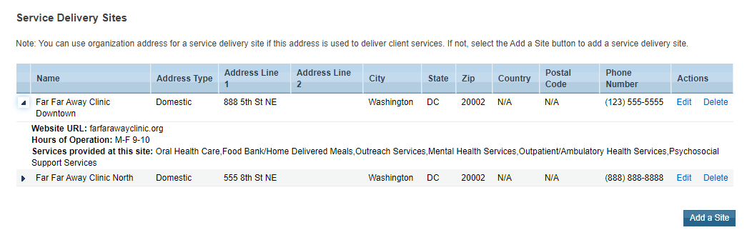
The following fields are included in the Service Delivery Sites section:
- Name: The name of the individual provider site.
- Address (including City, State, and ZIP): The address of the site where clients can receive services.
- Phone Number: The phone number of the site that clients should call to access services.
- Website URL: A web address related to the site.
There is a new validation alert in the Provider Report to check that a website URL is included for each Service Delivery Site. Please review your Service Delivery Sites and include a website URL whenever possible.
- Hours of Operation: The hours that a client can access services at this site. Hours of Operation is a text field where you can enter any details as needed to best describe the site’s operating hours.
- Services Provided at This Site: The services that clients are able to access at the specific site. Please make sure that all RWHAP, RWHAP-related, and EHE Initiative funded services are listed for one or more sites.
Once you have entered all required information, select “Save” at the bottom of the screen.

Program Information
The Program Information section of the RSR Provider Report contains additional questions about your organization, it’s funding sources, and your organization’s utilization of medication-assisted treatment (MAT) to treat opioid use disorder. Confirm that all required fields are complete and then select the “Save” button at the bottom-right of the screen.

Contact Information
Contact Information of person responsible for this submission: Enter the primary contact person for the RSR Provider Report. Please ensure the information here is accurate as HRSA HAB’s TA providers use the contact details in this section to reach out regarding any questions or concerns with the Provider Report submission. The fields included are:
- Name
- Title
- Phone
- Extension
- Fax
- Email

Clinical Quality Management Program Status
Select the status of your agency’s clinical quality management program (select only one): Further information on clinical quality management can be found in PCN #15-02 available on the HRSA HAB website.
- Clinical quality management program initiated this reporting period
- Previously established clinical quality management program
- Previously established program with new quality standards added this reporting period
- Do not have a clinical quality management program
Figure 29. RSR Provider Report: Screenshot of the Contact Information and Clinical Quality Management Program Status
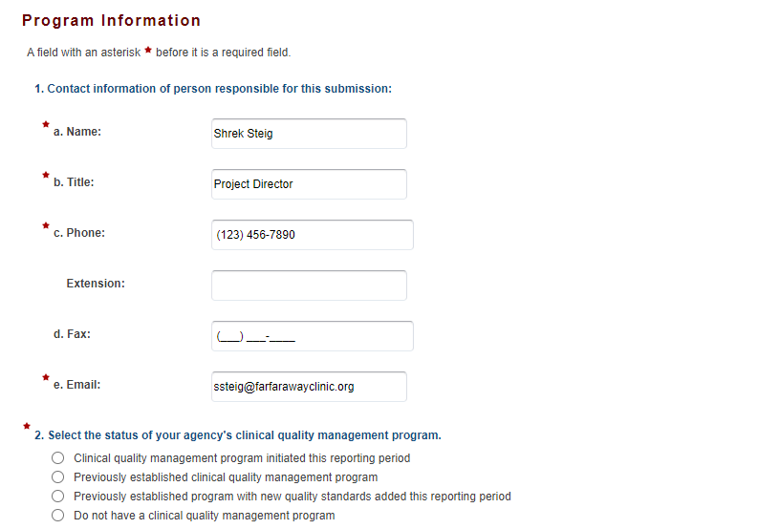

Funding Source Certification
This section lists all of your agency’s sources of RWHAP, RWHAP-related, and EHE funding (see Figure 30). Select the “+/- (Expand/Collapse)” icon to view the services funded through each funding source. Review the information in this list and verify that it is accurate by checking the box under the funding source table.
If a funding source is missing or the services listed are inaccurate, contact your recipient and ask them to amend their contracts in the web system. If a recipient that did not fund your organization is listed, contact Data Support for assistance at 1-888-640-9356 or via email at RyanWhiteDataSupport@wrma.com.
Figure 30. RSR Provider Report Online Form: Screenshot of the Funding Source Certification
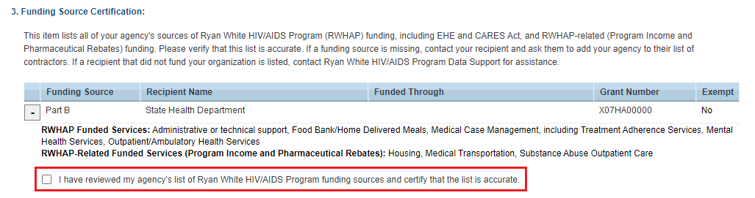

Opioid-Use Treatment
Questions 4, 5, and 6 of the Program Information section of the Provider Report all relate to your agency’s usage of medication-assisted treatment (MAT) to treat opioid use disorder (see Figure 31). Each field requires a response. Therefore, if your organization has no providers or clients to report, enter a “0” in that field.
For questions 4 and 5, providers should report information on all providers in the unit or subunit of their organization that are funded to provide RWHAP services (regardless of whether that unit or subunit is specifically funded to provide MAT through RWHAP).
For question 6, providers should report all eligible clients who were treated with MAT during the reporting period in the unit or subunit of their organization funded to provide RWHAP services.
- Within your organization/agency, identify the number of physicians, nurse practitioners, or physician assistants who obtained a Drug Addiction Treatment Act of 2000 (DATA) waiver to treat opioid use disorder with medications [medication-assisted treatment (MAT), e.g., buprenorphine, naltrexone] specifically approved by the U.S. Food and Drug Administration (FDA). Enter the number of the abovementioned staff who obtained the waiver in either the current year or prior years. Enter “0” if none of the abovementioned staff obtained the waiver.
- How many of the above physicians, nurse practitioners, or physician assistants prescribed MAT (e.g., buprenorphine, vivitrol) for opioid use disorders in the reporting period? Enter the number of the abovementioned staff who prescribed MAT. Enter “0” if none of the abovementioned staff prescribed MAT.
- How many RWHAP clients were treated with MAT during the reporting period? Enter the number of clients treated. Enter “0” if no clients were treated.
Figure 31. RSR Provider Report Online Form: Screenshot of the Opioid Reporting Questions
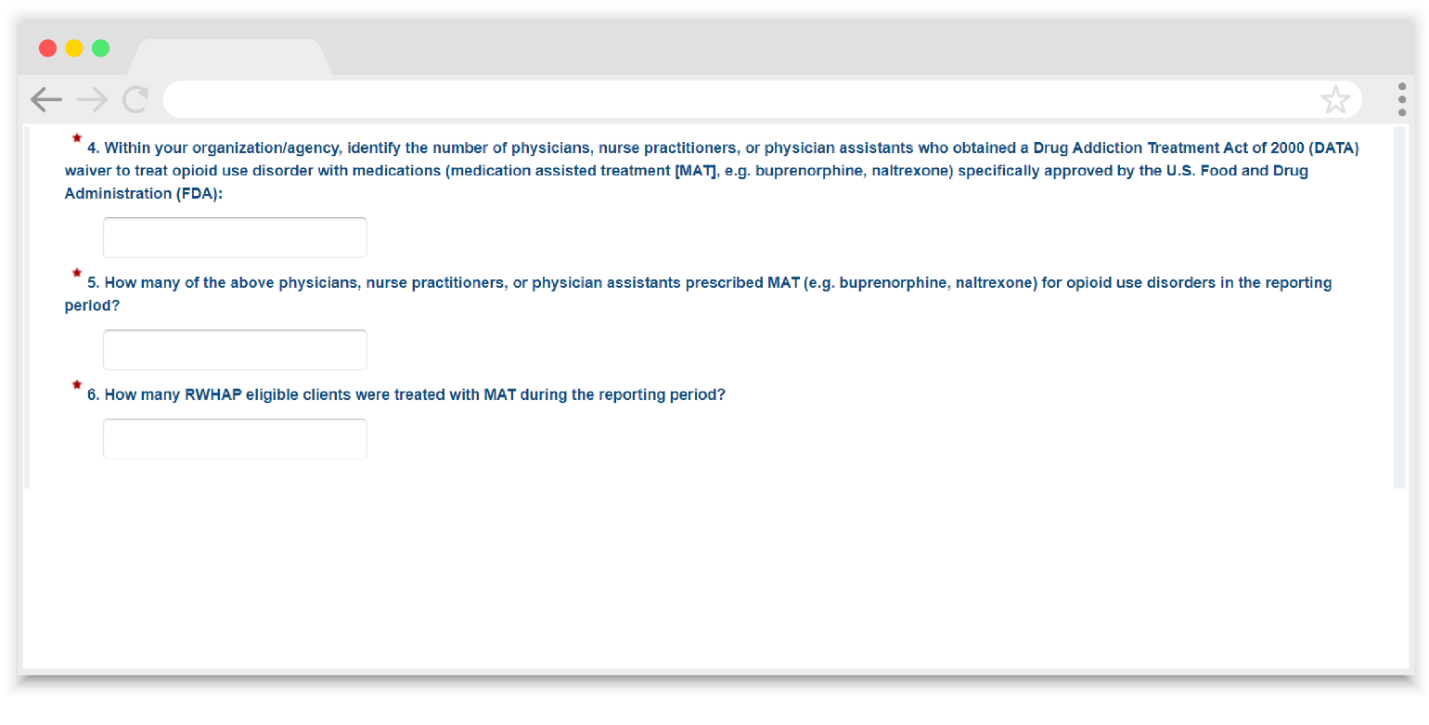

Service Information
The Service Information section of the RSR Provider Report is divided into two parts: the provider’s funded services (see Figure 32) and additional services (see Figure 33). The funded services are separated into four tables: Administrative and Technical Services, Core Medical Services, Support Services, and EHE Initiative Services.
Each table will list the services the provider was funded to provide as entered by their recipient(s) in their RSR Recipient Report(s) and includes all RWHAP, RWHAP-related, and EHE Initiative funding sources. Review the services in these tables and select the checkbox in the “Delivered” column for each service that your agency provided using RWHAP, RWHAP-related, or EHE Initiative funding during the reporting period. If a service category that was funded by your recipient is missing, contact the appropriate recipient to have it added to your report.
The Additional Services table at the bottom of the page is for providers who generate their own RWHAP-related funding (including program income and pharmaceutical rebates). Providers who generate their own RWHAP-related funding can select any additional services in this table that they deliver using that funding. Do not select any services in this table that are delivered solely with non-RWHAP or EHE funding sources.
Once you have finished marking your services, select the “Save” button at the bottom-right of the page.
The Additional Services table is only for services provided with the provider’s own RWHAP-related funding (including program income and pharmaceutical rebates). Do not select services in this table that your organization delivers only with non-RWHAP funding sources.
Figure 32. RSR Provider Report: Screenshot of the Service Information Funded Services
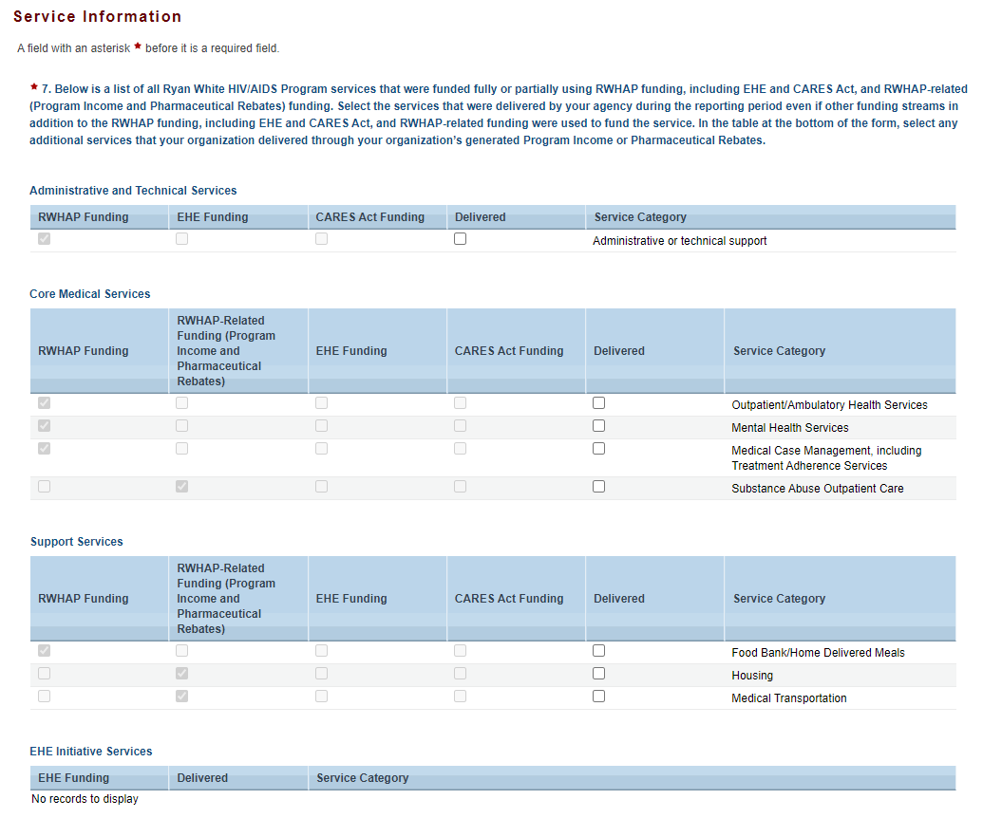

Figure 33. RSR Provider Report: Screenshot of Service Information Additional Services Table
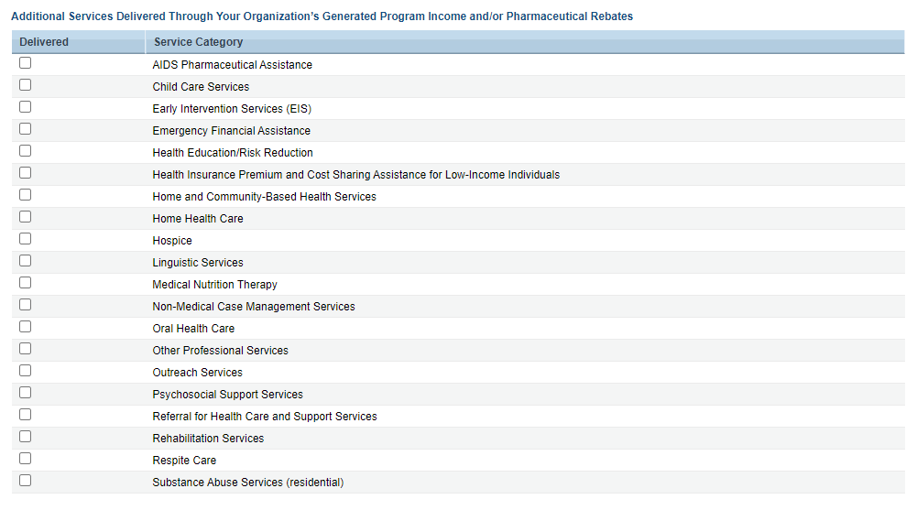

HIV Counseling and Testing Information
The HIV Counseling and Testing (HC&T) Information section of the RSR Provider Report (see Figure 34) contains five questions regarding your agency’s provision of HC&T services during the reporting period. You must provide aggregate data for HC&T services provided by your agency if you used RWHAP, RWHAP-related, or EHE Initiative funding to deliver HC&T services. This includes funding only used for staff salaries to provide HC&T services.
Report all clients who received the service at your agency during the reporting period, regardless of payor. If your agency did not provide HC&T services during the reporting period, select “No” for question #8. The fields will then automatically be grayed out and you do not need to enter data for questions #9-#12.
Once you are done entering your data on this page, make sure to select “Save” at the bottom-right of the screen.
Figure 34. RSR Provider Report: Screenshot of the HC&T Information Page
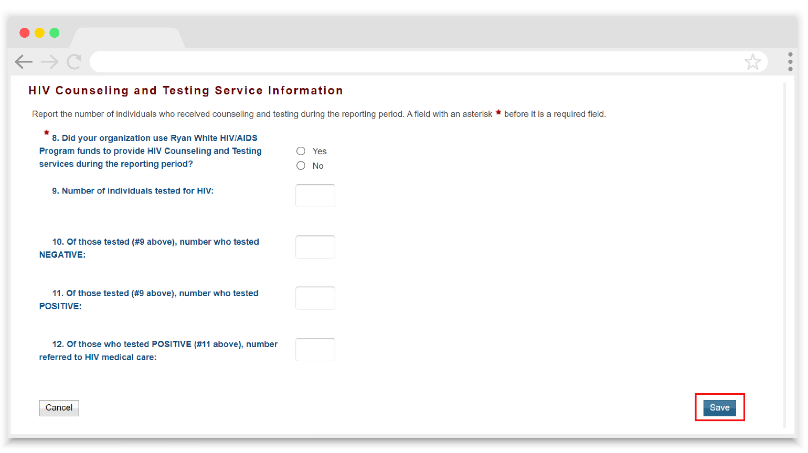
If you provide HC&T services as part of your Early Identification of Individuals with HIV/AIDS activities or under EIS for RWHAP Parts A, B, or C, report your HC&T data in this section.
- 8. Did your organization use RWHAP funds to provide HIV Counseling and Testing services during the reporting period? Indicate “Yes” or “No.”
- 9. Number of individuals tested for HIV: Indicate the number of people tested using an FDA-approved test during the reporting period.
- 10. Of those tested (#9 above), number who tested NEGATIVE: Of the total number tested, indicate the number who tested negative for HIV during the reporting period.
- 11. Of those tested (#9 above), number who tested POSITIVE: Of the total number tested, indicate the number who tested positive for HIV during the reporting period.
- 12. Of those who tested POSITIVE (#11 above), number referred to HIV medical care: Of the total number who tested positive for HIV, indicate how many were referred to HIV medical care.

Clients by ZIP Code
The Clients by ZIP Code section of the RSR Provider Report (see Figure 35) is where providers enter aggregate data on clients served by their ZIP Code of residence. Providers may manually enter the data directly onto the page or upload a file. The template file is available for download within this section of the report (see the Clients by ZIP Code template file link). In either case, the data entered in this section contain two fields:
- The ZIP Code of residence.
- The number of clients residing in that ZIP Code.
If your agency uses multiple data systems and your ZIP Code data are not able to be merged together easily, contact the DISQ Team for assistance at data.ta@caiglobal.org.
Only one file may be uploaded at a time to the Clients by ZIP Code section. Uploading a file will overwrite any data that were previously entered.
The clients reported in the Clients by ZIP Code section are the same clients that should be included in your client-level data file, i.e., eligible clients who received a service that your agency was funded to provide with either RWHAP, RWHAP-related, or EHE Initiative funding, regardless of payor.
The total number of clients reported in the Clients by ZIP Code section should match the total number of clients reported in your client-level data file(s). You will receive a validation alert if these values do not match.
There are instances where residence information may not be available for some clients or may be more difficult to discern. Special instructions cover the following groups:
- Clients who change residential ZIP Codes during the reporting period: Report the client’s most recent ZIP Code on file.
- Clients experiencing homelessness: Although many clients experiencing homelessness live doubled up or in shelters, transitional housing, or other fixed locations, others — especially those living on the street — do not know or will not share an exact location. When a ZIP Code location is unavailable or the location offered is questionable, providers should use the service location ZIP Code as a proxy.
- Clients with an unknown ZIP Code: When a ZIP Code location is unavailable or the location offered is questionable, providers should use the service location ZIP Code as a proxy. For the small number of patients with an unknown residence and who do not have a proxy, report the client’s ZIP Code as “99999” to indicate the residence is unknown.
Figure 35. RSR Provider Report: Screenshot of the Clients by ZIP Code Section
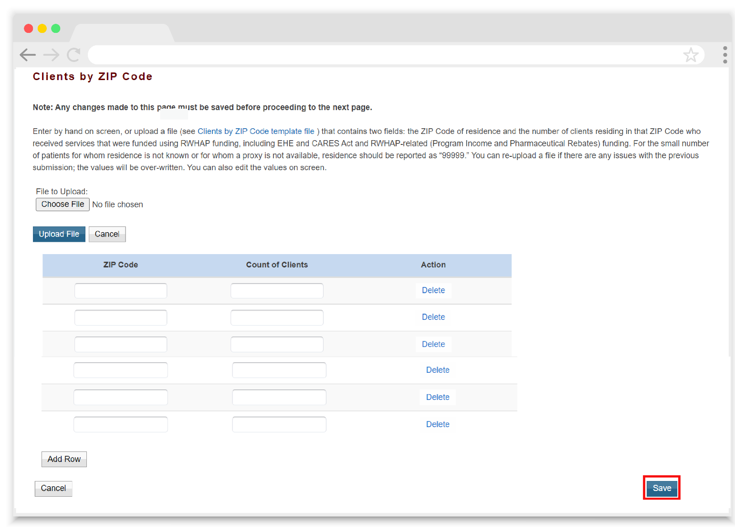

Import Client-level Data
If your agency provides direct services to clients, you must upload a client-level data file as part of your Provider Report. The client-level data file is a collection of client records that must be submitted in a properly formatted client-level data Extensible Markup Language (XML) file. For further guidance on the data elements included in the client-level data file, see RSR Client-level Data Report.
Your file should include a record for every eligible client that received at least one service that your agency was funded to provide with RWHAP, RWHAP-related, or EHE Initiative funding, regardless of payor.
To upload a file, select the “Choose File” button (see Figure 36), locate and select your data file saved on your computer, and finally select the “Upload File” button. The page will refresh and your file will be added to the “Upload History” table at the bottom of the page. The system must process your data file. Wait a couple minutes and then refresh the page by selecting “Import Client-level Data” in the Navigation panel on the left side of the screen or by refreshing through your web browser. You will know your file has finished processing once it moves to “Processed” status in the “Upload History” table and has a listed value for the “Clients in File” column.
Data files must be uploaded to the RSR Provider Report. Uploading to the Check Your XML feature does not meet the reporting requirements.
Figure 36. RSR Provider Report: Screenshot of the Import Client-level Data Section
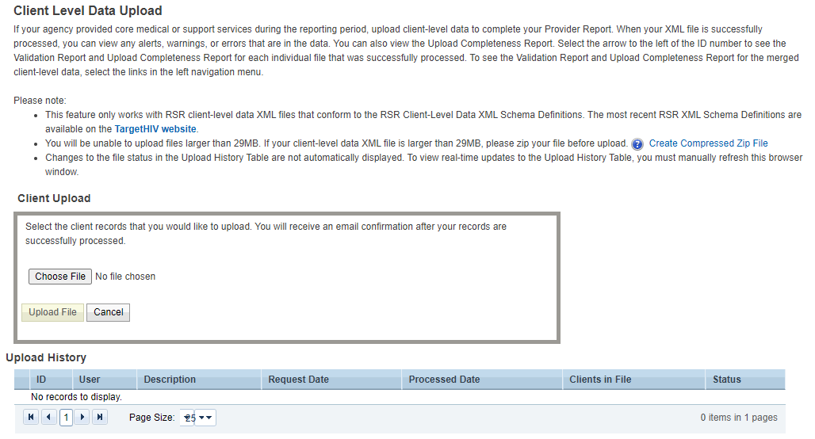
Each file uploaded into the RSR system goes through an automatic schema validation check to make sure that your file is formatted properly. If the file is noncompliant, the RSR system will reject the file, and a schema check error message will be displayed. Use the details in this error message to correct your data file before attempting to reupload your data.
If you need help correcting a schema check error, contact the DISQ Team at data.ta@caiglobal.org. Include a screenshot of the schema check error messages with your email.

Extracting Your Data
Providers need to extract the client-level data from their systems into the proper XML format before the data can be submitted to HRSA HAB. Software applications that manage and monitor HIV clinical and supportive care can export the data in the required XML format. Refer to RSR-Ready Data Systems Vendor Information on the TargetHIV website for a list of RSR-ready vendor systems that can generate the RSR client-level data XML file. If your organization uses a custom-built data collection system, you have two options:
- Write a program that extracts the data and inserts it into an XML file that conforms to the rules of the RSR XML schema as defined in the RSR Data Dictionary and XML Schema Implementation Guide for the Client-Level Data Report available on the TargetHIV website. These items are updated every year.
- Use TRAX to create your client-level data XML file. TRAX was developed to help recipients and providers that do not use CAREWare, a provider data import, or another RSR-ready vendor system to create their client-level data XML file.
If you need help generating or modifying your XML file, contact the DISQ Team at data.ta@caiglobal.org

Uploading Multiple Files
The RSR system allows for providers to upload multiple client-level data XML files if needed (if, for example, an agency utilizes more than one data system for their multiple recipients). Follow the instructions detailed in Import Client-level Data to upload each file individually.
The RSR system will merge the data files together based on the system’s merge logic. To review the system’s merge rules, see RSR Merge Rules on the TargetHIV website.

Removing an XML File
If you need to remove a client-level data file that you previously uploaded to your Provider Report, you may do so using the Clear Clients feature. In the Navigation panel on the left side of the screen, under the “Provider Report Actions” header, select “Clear Clients.”
The next page (see Figure 37) will display a table with all files that have been uploaded to your report. Select the checkbox on the left side of the table for each file that you wish to remove and then select the “Clear Selected File(s)” button at the bottom of the screen.
Data files are not removed from the system instantaneously. Instead the system will create a delete request while it processes the removal of your file(s) from your report. Wait a few minutes and then refresh the page. Once your file has been fully removed from your Provider Report, both the delete request and the file itself will no longer be listed.
Figure 37. RSR Provider Report: Screenshot of the Clear Clients Page
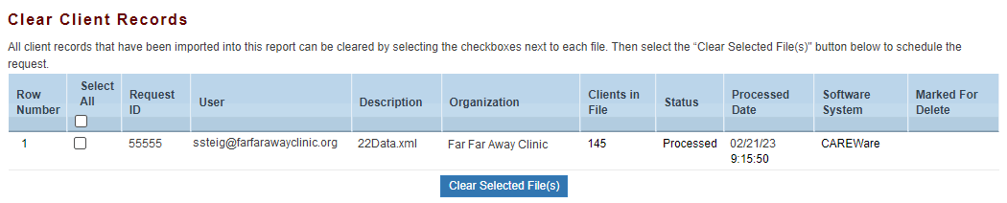

Validating the Provider Report
Once you have completed all sections of the Provider Report and uploaded your client-level data (if necessary), the next step is to validate your report. The validation process looks for any potential issues in your Provider Report and the client-level data file.
To validate your Provider Report, select “Validate” in the left Navigation panel on the left side of the screen under the “Provider Report Actions” header. The system will display a message indicating that your validation request is processing. Wait a few minutes and refresh the page by selecting “Validate” again in the Navigation panel. Once the validation process has completed, the system will display your validation results (see Figure 38).
Validation messages are divided into three categories:
- Errors must be corrected. You are not able to submit your report with an error. If an error is triggered by the Provider Report, correct the information entered the associated section of your report. If an error is triggered by the client-level data, you must correct the data file and re-upload it to the system. Be sure to clear the old file by using the “Clear Clients” feature (see Removing an XML File) to prevent any potential issues.
- Warnings should be corrected whenever possible but if you are unable to, you may still submit your report with a warning by adding a comment to your validation results that explains your agency’s situation as it relates to the validation message. To add a comment to a warning:
Select “Add Comment” under the “Actions” column to the right of the warning validation (see Figure 14).
A new window will appear for you to enter your comment.
When finished, select “Save” at the bottom of the text box.
Validation comments may not be deleted. Do not add validation comments until you are sure your data are ready to submit. If you have added a comment that you would like disregarded, add an additional comment with the correct explanation to the same validation message.
Do not include protected health information (PHI) or disclose sensitive information when entering a warning comment. For additional information about client confidentiality and privacy, visit the HHS Office of Civil Rights Health Information Privacy Page.
- Alerts should also be corrected whenever possible but if you are unable to, then you may still submit your report with an alert without taking any further action. However, it is highly recommended to correct all validation issues before submitting whenever possible.
If you have questions about a validation message you received, contact RyanWhite Data Support at 1-888-640-9356 or via email at RyanWhiteDataSupport@wrma.com.
If you make any changes to your report after validating, you must validate again before you are able to submit.
Figure 38. RSR Provider Report: Screenshot of the Validation Results Page
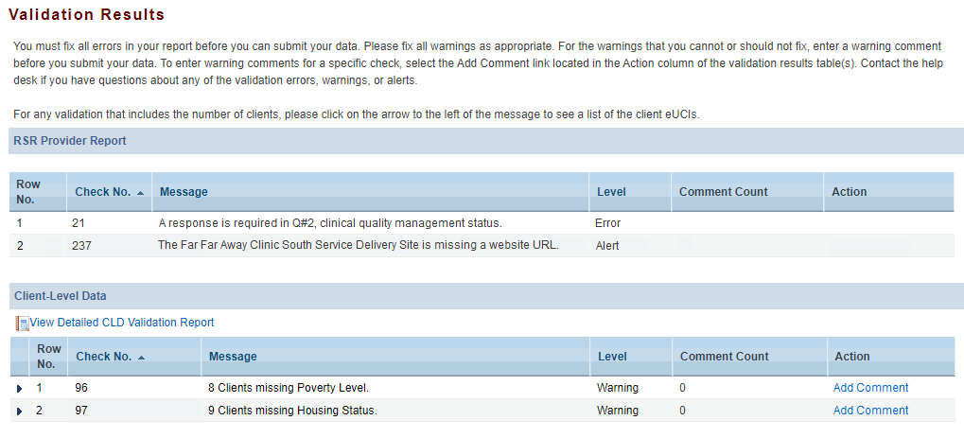

Submitting the Provider Report
When you are satisfied that your Provider Report is complete and you have taken care of any validation issues then you are ready to submit your report. To do so, select “Submit” in the Navigation panel on the left side of the screen under the “Provider Report Actions” header.
On the page that appears (see Figure 39), enter a comment in the text box with any meaningful feedback you have about the submission process. These comments are reviewed each submission period for any potential issues or enhancements that could be made to the web system.
Next, check the box under the comment box indicating that you certify the data in the report are accurate and complete. Lastly, select the “Submit Report” button.
Your RSR Provider Report will proceed to either “Review” or “Submitted” status. If your report advances to “Submitted” status, you are done. If your report advances to “Review” status, one or more recipients must review and accept the report before it will advance to “Submitted” status.
If you have questions about the status of your RSR, contact Ryan White Data Support at 1-888-640-9356 or via email at RyanWhiteDataSupport@wrma.com.
Figure 39. RSR Provider Report: Screenshot of the Submit Report Page
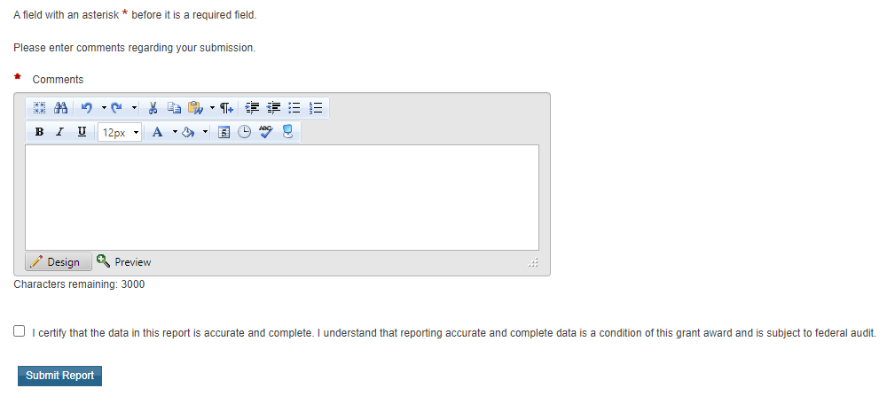

Accepting the Provider Report
When a Provider Report is in “Review” status, then one or more recipients that fund the associated provider must accept the report before it will move into “Submitted” status. It is the recipient’s responsibility to review their providers’ reports and data for accuracy and completeness. Each Provider Report must be accepted through all grants that are listed in the report. This includes instances where a recipient funds a provider or themselves with multiple of their own grants (e.g., a provider that is also a RWHAP Part C and D recipient must accept their own Provider Report through both their RWHAP Part C and RWHAP Part D grant).
To accept your providers’ reports, begin by navigating to the RSR Provider Report Inbox (see Accessing the RSR Provider Report for more detailed instructions). Open the Provider Report by selecting the envelope icon in the “Action” column. Review the agency’s report completely including the following:
- All Provider Report sections (e.g., General Information, Program Information, etc.)
- Upload Completeness Report
- Validation results
Once you have finished reviewing the provider’s report, use the links in the Navigation panel on the left side of the screen under the “Provider Report Actions” header (see Figure 40) to either accept the report (by selecting “Submit/Accept”) or return it back to the provider for necessary corrections (by selecting “Return for Changes”).
If you return the report to the provider for changes, be sure include in the comment text box any revisions you would like the provider to make to their report.
Your RSR Recipient Report will not advance to “Submitted” status until you have accepted all of your providers’ reports. If you are unsure which recipients and/or grants need to accept your providers’ reports, you can view the “Action History” of the Provider Report to see the recipients and grants that have accepted the report and how many recipients still must accept the report. But if you are still unsure, please reach out to Ryan White Data Support for assistance.
Recipients that fund a single provider with more than one grant, such as RWHAP Parts C and D grants or RWHAP Part and EHE awards, must accept the Provider Report through both grants before it will advance to “Submitted” status.
If you need help reviewing your providers’ reports or are unsure which reports you need to accept, contact Ryan White Data Support at 1-888-640-9356 or via email at RyanWhiteDataSupport@wrma.com.
Figure 40. RSR Provider Report: Screenshot of the Navigation Panel Provider Report Actions
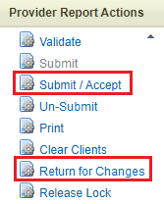

Frequently Asked Questions About the RSR Provider Report

Do providers that receive funding from multiple RWHAP Parts complete multiple Provider Reports?
No, each agency will submit only one Provider Report including data for all RWHAP, RWHAP-related, and EHE Initiative funding sources.
Are providers that the recipient does not have a formal contract with required to submit data?
For the purpose of the RSR, “contracts” include formal contracts, memoranda of understanding, or other agreements. Data must be reported for all providers that delivered funded services.
Do providers need to submit a Provider Report and client-level data if they do not serve any clients, submit only vouchers, only serve clients on a fee-for-service basis, or receive a small amount of funding from my grant?
Each provider listed on your contract list will be required to complete an RSR Provider Report unless all of its recipients have marked it as exempt. Data are still required of all providers that delivered funded services. Please refer to Provider Exemptions to review how to report for an exempted provider or if an exemption is appropriate.
Do second-level providers have to submit Provider Reports?
Yes, both subrecipients and second-level providers need to complete Provider Reports and provide client-level data (if they delivered direct-client services).
I have a lot of providers and have set an early submission deadline so I have time to review their submissions. But one of my providers is multiply funded, and the other recipient told my provider that it does not need to submit its data until HRSA HAB’s recommended submission deadline. I really need my provider to submit its data early. What do I do?
Contact your provider’s other recipient(s), preferably before the report submission period begins, to coordinate your deadlines. Taking the time upfront to agree on the submission deadlines that all the provider’s recipients will enforce will help ensure a smooth submission process. If your provider is also a recipient, be sure to negotiate an early submission deadline that is agreeable to both of you. Project officers can be helpful in these decisions and can suggest due dates for reports.
How do I update my General Information section of the Provider Report? Whenever I make a change and synchronize, my changes are deleted from the report?
Providers that use the Service Provider login portal (i.e., providers who are not also a direct grant recipient) should update these details in their Provider Profile, accessible through the Organization Home page (see General Information for further instructions). For recipients completing their own report or the report of one of their providers that need to make changes to the Organization Details, Organization Contacts, or Provider Profile Information, please contact Ryan White Data Support at 1-888-640-9356 or via email at RyanWhiteDataSupport@wrma.com.
When completing the opioid-use treatment questions in the Provider Report, should we count providers covered under a subcontract?
Yes, include subcontract providers.
If our agency has a separate non-RWHAP-funded program that provides MAT for opioid use, do we need to report on these clients?
No, only report all eligible clients who were treated with MAT during the reporting period in the unit or subunit of the organization funded to provide RWHAP services.
For the opioid-use treatment questions about how many clients were treated with MAT during the reporting period, should we include the eligible patients who received or were prescribed MAT at an outside organization?
No, only report eligible clients who were treated with MAT during the reporting period in the unit or subunit of the organization funded to provide RWHAP services.
How do I report a service that I delivered that does not appear in my Provider Report?
If you receive RWHAP, RWHAP-related, or EHE Initiative funding from a recipient to deliver a service that is not populated in your Provider Report, contact your recipient to add the service to their Recipient Report. If a service that was funded using your own RWHAP-related funding is missing, click the corresponding checkbox in the Additional Services table in the Service Information section of your Provider Report to add the service. If you did not receive RWHAP, RWHAP-related, or EHE Initiative funding to deliver the service, do not mark it in your Provider Report.
My agency is receiving a validation message in our validation results saying that services were delivered but not uploaded. We selected the service category in the Additional Services table of the Service Information since we deliver the service, just not with any RWHAP funding source. How do we remove this validation?
The Additional Services table in the Service Information is only for services that the provider uses their own RWHAP-related funding (including program income and pharmaceutical rebates) to provide. Services not provided with any RWHAP, RWHAP-related, or EHE Initiative funding should not be selected in this table. Remove the selection that was made in the Additional Services table and revalidate your report to resolve the validation message.
In the Clients by ZIP Code section, do we report the ZIP Code of the client’s home address or where the client receives services?
Report the ZIP Code of the client’s home address. If the ZIP Code of a client’s home address is not known or the client is experiencing homelessness, then report the ZIP Code of the location where the client receives services as a proxy.
Do I submit the ZIP Codes of all clients seen by my agency or just RWHAP clients?
The clients reported in the Clients by ZIP Code section are the same clients that should be reported in the provider’s client-level data file. In other words, eligible clients who received at least one service during the reporting period that the provider was funded to provide with RWHAP, RWHAP-related, or EHE Initiative funding, regardless of payor.
How do I report the ZIP Code of a client who has moved during the reporting period?
If a client has changed ZIP Codes during the reporting period, report the most recent known ZIP Code for that client.
How do I report the ZIP Code of homeless clients?
When a ZIP Code location is unavailable for a homeless client or the location offered is questionable, providers should use the service location ZIP Code as a proxy.
How do I report a client in the Clients by ZIP Code section if his or her ZIP Code is unknown?
Providers should use the service location ZIP Code as a proxy. For the small number of clients for whom residence is not known and for whom a proxy is not available, report the client’s ZIP Code as “99999” to indicate that the residence is unknown.
Can I upload more than one ZIP Code file?
No. Providers may upload one .csv file that includes their ZIP Codes using the provided template. The system only accepts one file at a time; when a second file is uploaded, the first file’s data will be erased and overwritten.
How do I determine whether or not a client should be reported in the 2022 RSR client-level data?
Providers should report client-level data for all eligible clients who received a service for which the provider received RWHAP, RWHAP-related (including program income and pharmaceutical rebates), or EHE Initiative funding to provide, regardless of payor. See Eligible Services Reporting for further information.
How do I remove a client-level data file from my Provider Report?
Providers can delete a previously uploaded client-level data XML file by using the “Clear Clients” feature. See Removing an XML File for further instructions.
Why has my Provider Report not moved into “Submitted” status even though the report has been accepted?
A Provider Report will only be moved to “Submitted” status if all funding recipients have accepted the report. If you fund the provider with more than one of your own grants, you must accept the report through all of them. See Accepting the Provider Report for further assistance.

RSR Client-Level Data Report
Client-level data must be submitted for all providers who were funded with RWHAP, RWHAP-related, or EHE Initiative funding to provide core medical or support services directly to clients during the reporting period. Unless exempted from reporting, all provider agencies must complete their own reports to confirm that their data accurately reflect their program and the quality of care their agency provides.
Providers must upload their client-level data in a properly formatted XML file directly to their Provider Report. They may also test their data files before the Provider Report system formally opens by using the Check Your XML feature (see Checking the Client-level Data XML File below).
This section of the manual contains additional information for reviewing your data file, the tools available in the system to check your data, and a detailed explanation of each of the possible data elements that could be included in a client’s record.

Checking the Client-level Data XML File
The Check Your XML feature — available to users before the RSR Recipient Report opens — allows providers to confirm that their XML file complies with the latest RSR client-level data schema. It also allows agencies to validate their data and helps identify specific data issues prior to final submission. To access the Check Your XML feature, from the RSR Provider Report Inbox (see Accessing the RSR Provider Report for detailed instructions on getting to this point) select “Check Your XML” in the Navigation panel on the left side of the screen under the “Inbox” header. For further instructions on utilizing the Check Your XML tool, see the RSR Check Your XML Feature webinar available on the TargetHIV website.
Your data must be uploaded to the RSR Provider Report. Data uploaded into the Check Your XML are not submitted to HRSA HAB.
The RSR system contains an additional helpful tool to help agencies check their data prior to submission. The Upload Completeness Report (UCR) is a web system generated report available in both the Check Your XML feature and in the RSR Provider Report. The UCR contains a breakdown of the data elements included in the client-level data file with aggregate counts of clients for each response option.
The UCR allows you to review your data completeness and data qualify and to identify both missing data and incorrect data. You can generate the UCR in both the Check Your XML feature and within the RSR Provider Report after uploading your data and selecting “Upload Completeness Report” in the Navigation panel on the left side of the screen. For additional assistance utilizing the UCR, please see RSR in Focus: How to Use the RSR Upload Completeness Report and the RSR Upload Completeness Report Training Module, both available on the TargetHIV website.

Client-level Data Elements
The client-level data file should contain one record for each eligible client who received at least one service during the reporting period that the provider received RWHAP, RWHAP-related, or EHE Initiative funding to provide, regardless of payor. The data elements reported per client are determined by the specific services that they received. To see what data elements are required for each service category, please see Appendix A.
Up to 56 data elements may be reported for each client; they include the following:
- Encrypted Unique Client Identifier (eUCI)
- Demographic information
- Core medical and support services received
- Clinical information (required if the client received Outpatient/Ambulatory Health Services)
Figure 45. Screenshot of Client-Level Data Element and Element ID
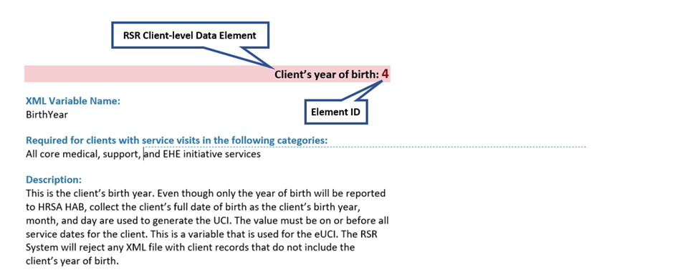
Each data element description (see Figure 45) includes the following:
Element ID: Each data element has been assigned a value for convenient referencing between this document and the RSR Data Dictionary and XML Schema Implementation Guide available on the TargetHIV website.
RSR Client-level Data Element: A brief description of the client-level data element being collected.
XML Variable Name: The data elements have been assigned a variable name in the RSR Data Dictionary as the way to label data in the client-level data XML file. The variable name is provided for convenient referencing between this document and the RSR Data Dictionary.
Required for clients with service visits in the following categories: The data elements that must be reported for your clients are based on the types of services they receive that your agency is funded to provide. Report the data element for all eligible clients who receive the service, regardless of payor.
Description: A detailed discussion, if required, of the variable and responses that may be reported for the variable. This section defines the responses allowed for the data element.
Frequently asked questions about this data element: Where applicable, answers are provided to the questions asked by recipients and providers the most about the data element.
The table below lists all the possible data elements with links to their descriptions in this section of the manual:
Table 1: RSR Client-level Data Elements
Element Id | Data Element Name
SV2 | RSR system’s unique provider ID
SV3 | RSR system’s unique provider registration code
SV4 | Client’s encrypted Unique Client Identifier
2 | Client’s vital status at the end of the reporting period
4 | Client’s year of birth
5 | Client’s self-reported ethnicity
68 | Client report Hispanic subgroup
6 | Client’s self-reported race
69 | Client report Asian subgroup
70 | Client report Native Hawaiian/Pacific Islander (NHPI) subgroup
7 | Client’s current self-reported gender
71 | Client sex at birth
9 | Client’s percent of the federal poverty level
10 | Client’s housing status
11 | Client’s housing status collection date
12 | Client’s HIV/AIDS status
14 | Client’s risk factor for HIV
15 | Client’s health coverage
72 | HIV diagnosis year
76 | New client
77 | Received service previous year
16, 18-19, 21-27, 28-44, 75, 78 | Service visits delivered
17, 20 | Core medical services delivered
47 | Date client’s first HIV outpatient/ambulatory health service visit
48 | Dates of the client’s outpatient/ambulatory health service visits
49 | Client’s CD4 test
50 | Client’s viral load test
52 | Client prescribed ART
55 | Client was screened for syphilis during this reporting period
64 | Client was pregnant
73 | Positive HIV test date
74 | Outpatient/ambulatory health service link date

System Identifiers

RSR system’s unique provider ID: SV2
XML Variable Name:
ProviderID
Description:
The unique provider organization identifier assigned through the RSR web system.

RSR system’s unique provider registration code: SV3
XML Variable Name:
RegistrationCode
Description:
The unique provider registration code assigned through the RSR web system.

Client’s encrypted Unique Client Identifier: SV4
XML Variable Name:
ClientUci
Required for clients with service visits in the following categories:
All core medical and support services
Description:
To protect client information, an encrypted Unique Client Identifier (eUCI) is used for reporting RSR client-level data. Using eUCIs allows HRSA HAB to deduplicate the clients and obtain a more accurate count of the clients’ services.
Note: Your data system contains personal health information that includes, but is not limited to, client names, addresses, DOB, SSN, dates of service, and URNs generated for your organization’s client-level data XML file. To ensure client confidentiality, you must be compliant with all relevant federal regulations. Protect this information the same way you protect all client data. Do not disclose sensitive information in your reporting comments. Refer to Health Information Privacy on the HHS website for additional information about client confidentiality and privacy.
To learn more about the eUCI, including rules on how to construct the UCI before encryption, view the Encrypted Unique Client Identifier (eUCI): Application and User Guide on the TargetHIV website.

Guidelines for Collecting and Recording Client Names
Agencies should develop business rules/operating procedures outlining the method by which client names are collected and recorded. For example:
- Enter the client’s entire name as it normally appears on documentation such as a driver’s license, birth certificate, passport, or Social Security card.
- Follow the naming patterns, practices, and customs of the local community or region (e.g., for Hispanic clients living in Puerto Rico, record both surnames in the appropriate order).
- Avoid using nicknames (e.g., do not use Becca if the client’s first name is Rebecca).
- Avoid using initials.
Instruct providers and staff on how to enter their client’s names. This is especially true when clients receive services from multiple providers in a network. To avoid false duplicates, client names must be entered in the same way at each provider location so that the client has the same eUCI.

Frequently Asked Questions About This Data Element
What if I am missing data elements that compose the eUCI?
If you are missing data elements required for the eUCI, do everything possible to obtain those data elements. They are required for each client. This effort will improve not only the quality of data linking but also patient care and case management.

Demographic Data
You can report up to 18 demographic data elements for each client. Determine which demographic data elements are required for a particular client by reviewing Appendix A.

Client’s vital status at the end of the reporting period: 2
XML Variable Name:
VitalStatusID
Required for clients with service visits in the following categories:
- Outpatient/Ambulatory Health Services
- Medical Case Management
- Non-Medical Case Management
- EHE Initiative Services
Description:
This is the client’s vital status at the end of the reporting period. Response categories for this data element are:
- Alive
- Deceased
- Unknown

Frequently Asked Questions About This Data Element
How do I report a client who is no longer receiving services?
If a client is no longer receiving services (i.e., the client is no longer active due to referral, relocation, or any other reason), report the client’s last known status.
Our agency stopped receiving RWHAP funding during the reporting period. How do I report vital status for our clients?
HRSA HAB recommends that providers report the vital status associated with the client at the time funding ended.

Client’s year of birth: 4
XML Variable Name:
BirthYear
Required for clients with service visits in the following categories:
All core medical, support, and EHE Initiative services
Description:
This is the client’s birth year. Even though only the year of birth will be reported to HRSA HAB, collect the client’s full date of birth, as the client’s birth year, month, and day are used to generate the eUCI. The value must be on or before all service dates for the client.

Guidelines for Reporting Client Race and Ethnicity
Office of Management and Budget (OMB) Revisions to the Standards for the Classification of Federal Data on Race and Ethnicity provides a minimum standard for maintaining, collecting, and presenting data on race and ethnicity for all federal reporting purposes. The standards were developed to provide a common language for uniformity and comparability in the collection and use of data on race and ethnicity by federal agencies.
The standards have five categories for data on race: American Indian or Alaska Native, Asian, Black or African American, Native Hawaiian or Other Pacific Islander, and White. There are two categories for data on ethnicity: Hispanic or Latino and Not Hispanic or Latino. In addition, identification of ethnic and racial subgroups is required for the categories of Hispanic/Latino, Asian, and Native Hawaiian/Pacific Islander. The racial category descriptions, defined in October 1997, are required for all federal reporting as mandated by the OMB.
HRSA HAB is required to use the OMB reporting standard for race and ethnicity. However, service providers should feel free to collect race and ethnicity data in greater detail. If the agency chooses to use a more detailed collection system, the data collected must be organized so that any new categories can be aggregated into the standard OMB breakdown.
Providers are expected to make every effort to obtain and report race and ethnicity based on each client’s self-report. Self-identification is the preferred means of obtaining this information. Providers should not establish criteria or qualifications to use to determine a particular person’s racial or ethnic classification, nor should they specify how someone should classify himself or herself.

Client’s self-reported ethnicity: 5
XML Variable Name:
EthnicityID
Required for clients with service visits in the following categories:
All core medical, support, and EHE Initiative services
Description:
The client’s ethnicity based on his or her self-report. These are the response category options:
- Hispanic/ Latino/a—A person of Cuban, Mexican, Puerto Rican, South or Central American, or other Spanish culture or origin, regardless of race. The term “Spanish origin” can be synonymous with “Hispanic or Latino.” If a client identifies as Hispanic/Latino/a or Spanish origin, choose all Hispanic subgroups that apply in ID 68.
- Non-Hispanic/Latino/a—A person who does not identify his or her ethnicity as “Hispanic or Latino.”

Client report Hispanic subgroup: 68
XML Variable Name:
HispanicSubgroupID
Required for clients if EthnicityID is Hispanic/Latino(a) or Spanish origin with service visits in the following categories:
All core medical, support, and EHE Initiative services
Description:
If the response to ID 5, client’s self-reported ethnicity, is “Hispanic/Latino/a,” indicate the client’s Hispanic subgroup (choose all that apply).
These are the response category options:
- Mexican, Mexican American, Chicano/a
- Puerto Rican
- Cuban
- Another Hispanic, Latino/a or Spanish origin

Client’s self-reported race: 6
XML Variable Name:
RaceID
Required for all clients with service visits in the following categories:
All core medical, support, and EHE Initiative services
Description:
This is the client’s race based on his or her self-report. Multiracial clients should select all categories that apply.
- American Indian or Alaska Native—A person having origins in any of the original peoples of North and South America (including Central America), and who maintains tribal affiliation or community attachment.
- Asian—A person having origins in any of the original peoples of the Far East, Southeast Asia, or the Indian subcontinent including, for example, Cambodia, China, India, Japan, Korea, Malaysia, Pakistan, the Philippine Islands, Thailand, and Vietnam. If a client identifies as Asian, choose all Asian subgroups that apply in ID 69.
- Black or African American—A person having origins in any of the black racial groups of Africa.
- Native Hawaiian or Pacific Islander—A person having origins in any of the original peoples of Hawaii, Guam, Samoa, or other Pacific Islands. If a client identifies as Native Hawaiian/Pacific Islander, choose all Native Hawaiian/Pacific Islander subgroups that apply in ID 70.
- White—A person having origins in any of the original peoples of Europe, the Middle East, or North Africa.

Client report Asian subgroup: 69
XML Variable Name:
AsianSubgroupID
Required for clients if RaceID is Asian with service visits in the following categories:
All core medical, support, and EHE Initiative services
Description:
If the response to ID 6, client’s self-reported race, is “Asian,” indicate the client’s Asian subgroup (choose all that apply).
These are the response category options:
- Asian Indian
- Chinese
- Filipino
- Japanese
- Korean
- Vietnamese
- Other Asian

Client report Native Hawaiian/Pacific Islander (NHPI) subgroup: 70
XML Variable Name:
NHPISubgroupID
Required for clients if RaceID is Native Hawaiian/Pacific Islander with service visits in the following categories:
All core medical, support, and EHE Initiative services
Description:
If the response to ID 6, client’s self-reported race, is “Native Hawaiian or Other Pacific Islander,” indicate the client’s Native Hawaiian/Pacific Islander subgroup (choose all that apply).
- Native Hawaiian
- Guamanian or Chamorro
- Samoan
- Other Pacific Islander

Client’s current self-reported gender: 7
XML Variable Name:
GenderID
Required for clients with service visits in the following categories:
All core medical, support, and EHE Initiative services
Description:
Indicate the client’s gender (the socially and psychologically constructed, understood, and interpreted set of characteristics that describe the current sexual identity of an individual) based on his or her self-report. Gender cannot be missing; one of the options below must be reported for current gender. This is a variable that is used for the eUCI.
- Male—An individual with strong and persistent identification with the male gender.
- Female—An individual with strong and persistent identification with the female gender.
- Transgender Male to Female—An individual whose sex assigned at birth was male but identifies their gender as female, regardless of the status of social gender transition or surgical and hormonal sex reassignment processes.
- Transgender Female to Male—An individual whose sex assigned at birth was female but identifies their gender as male, regardless of the status of social gender transition or surgical and hormonal sex reassignment processes.
- Transgender Other—An individual who does not identify with the other transgender options and/or does not identify with the binary positions of male/female. These individuals may or may not engage in social gender transition or surgical and hormonal sex reassignment processes (e.g., gender nonconforming, genderqueer, nonbinary, gender fluid, bigender, two-spirited).
- Unknown—Indicates the client’s gender category is unknown, was not reported, or does not fit within one of the available options.

Client sex at birth: 71
XML Variable Name:
SexAtBirthID
Required for clients with service visits in the following categories:
All core medical, support, and EHE Initiative services
Description:
The biological sex assigned to the client at birth.
- Male
- Female

Client’s percent of the federal poverty level: 9
XML Variable Name:
PovertyLevelPercent
Required for clients with service visits in the following categories:
- Outpatient/Ambulatory Health Services
- Medical Case Management
- Non-Medical Case Management
- EHE Initiative Services
Description:
This is the client’s income in terms of the percent of the federal poverty level at the end of the reporting period. Enter up to four digits in the data entry field. No decimals are allowed.
If your organization collects this information early in the reporting period, it is not necessary to collect it again at the end of the reporting period (although you should document changes). Report the latest information on file for each client.
There are two slightly different versions of the federal poverty measure—the poverty thresholds (updated annually by the U.S. Bureau of the Census) and the poverty guidelines (updated annually by HHS). For more information on poverty measures and to see the most recent HHS Poverty Guidelines, go to Poverty Research on the HHS website.
If your agency already uses the U.S. Bureau of the Census poverty thresholds to calculate this data element, continue to do so. Otherwise, HRSA HAB recommends (and prefers) that you use the HHS poverty guidelines to collect and report these data.

Client’s housing status: 10
XML Variable Name:
HousingStatusID
Required for clients with service visits in the following categories:
- Outpatient/Ambulatory Health Services
- Medical Case Management
- Non-Medical Case Management
- Housing Services
- EHE Initiative Services
Description:
This data element is the client’s housing status at the end of the reporting period. There are three response categories for this data element:
- Stable Permanent Housing
- Temporary Housing
- Unstable Housing
Stable Permanent Housing includes the following:
- Renting and living in an unsubsidized room, house, or apartment
- Owning and living in an unsubsidized house or apartment
- Unsubsidized permanent placement with families or other self-sufficient arrangements
- HOPWA-funded housing assistance, including Tenant-Based Rental Assistance or Facility-Based Housing Assistance, but not including the Short-Term Rent, Mortgage and Utility Assistance Program
- Subsidized, non-HOPWA, house or apartment, including Section 8, the HOME Investment Partnerships Program, and public housing
- Permanent housing for formerly homeless persons, including Shelter Plus Care, the Supportive Housing Program, and the Moderate Rehabilitation Program for Single Room Occupancy (SRO) Dwellings
- Institutional setting with greater support and continued residence expected (psychiatric hospital or other psychiatric facility, foster care home or foster care group home, or other residence or long-term care facility)
Temporary Housing includes the following:
- Transitional housing for people experiencing homelessness
- Temporary arrangement to stay or live with family or friends
- Other temporary arrangement such as a RWHAP-housing subsidy
- Temporary placement in an institution (e.g., hospital, psychiatric hospital or other psychiatric facility, substance use disorder treatment facility, or detoxification center)
- Hotel or motel paid for without emergency shelter voucher
Unstable Housing includes the following:
- Emergency shelter or a public or private place not designed for, or ordinarily used as, a regular sleeping accommodation for humans, including a vehicle, an abandoned building, a bus/train/subway station/airport, or anywhere outside
- Jail, prison, or a juvenile detention facility
- Hotel or motel paid for with emergency shelter voucher
These definitions are based on:
- HOPWA Program, Annual Progress Report, Measuring Performance Outcomes, form HUD-40110-C
- McKinney-Vento Act, Title 42 US Code, Sec. 11302, General definition of homeless person

Client’s housing status collection date: 11
XML Variable Name:
HousingStatusCollectedDate
Required for clients with service visits in the following categories:
- Outpatient/Ambulatory Health Services
- Medical Case Management
- Non-Medical Case Management
- Housing Services
- EHE Initiative Services
Description:
This data element is the most recent date the client’s housing status was collected. The date must be within the reporting period and in the format:
- MM/DD/YYYY

Client’s HIV/AIDS status: 12
XML Variable Name:
HIVAidsStatusID
Required for clients with service visits in the following categories:
- Outpatient/Ambulatory Health Services
- Medical Case Management
- Non-Medical Case Management
- EHE Initiative Services
Description:
This data element is the client’s HIV status at the end of the reporting period. For HIV-affected clients with an unknown HIV status, leave this value blank. The response categories for this element are:
- HIV-negative (affected)—Client has tested negative for HIV or is an affected partner or family member of a person who is HIV positive and has received at least one support service during the reporting period.
HIV-affected clients are clients who are HIV negative or have an unknown HIV status. An affected client must be linked to a client/person with HIV.
- HIV-positive, not AIDS—Client has diagnosed HIV but not diagnosed AIDS.
- HIV-positive, AIDS status unknown—Client has diagnosed HIV. It is not known whether the client has diagnosed AIDS.
- CDC-defined AIDS—Client has HIV and meets the CDC AIDS case definition for an adult or child. NOTE: Once a client has AIDS, he or she is always counted in the CDC-defined AIDS category regardless of changes in CD4 counts.
- HIV-indeterminate (infants <2 years only)—A child under the age of 2 years whose HIV status is not yet determined but was born to a woman with HIV.
Once an HIV-indeterminate (infants <2 years only) client is confirmed HIV-negative, he or she must be reclassified as an HIV-affected client.

Frequently Asked Questions About This Data Element
What is the operational definition of AIDS?
HRSA HAB uses the current CDC surveillance case definition for Acquired Immunodeficiency Syndrome for national reporting. For additional information, see:
- Revised Surveillance Case Definition for HIV Infection
— United States, 2014

Client’s risk factor for HIV: 14
XML Variable Name:
HIVRiskFactorID
Required for clients with service visits in the following categories:
- Outpatient/Ambulatory Health Services
- Medical Case Management
- Non-Medical Case Management
- EHE Initiative Services
Description:
This data element is the client’s initial risk factor for HIV transmission. Report all the response categories that apply. It is primarily based on self-report. For HIV-affected clients for whom HIV status is not known, leave this value blank.
- Male-to-male sexual contact cases include men who report sexual contact with other men (i.e., same-sex contact) and men who report sexual contact with both men and women (i.e., bisexual contact).
- Injection drug use cases include clients who report receiving an injection, either self-administered or by another person, of a drug that was not prescribed by a physician for this person. The drug itself is not the source of the HIV infection but rather the sharing of syringes or other injection equipment (e.g., cookers and cottons), which can result in transmission of bloodborne pathogens such as HIV.
- Hemophilia/coagulation disorder cases include clients with delayed clotting of the blood.
- Heterosexual contact cases include clients who report specific heterosexual contact with an individual known to have, or to be at high risk for, HIV infection (e.g., an injection drug user or a man who has sex with men).
- Receipt of transfusion of blood, blood components, or tissue cases include transfusion-transmitted HIV through receipt of infected blood or tissue products given for medical care.
- Perinatal transmission cases include transmission from mother to child during pregnancy or childbirth. This category is exclusively for clients with perinatally acquired HIV. This category includes clients born after 1980 who are known to have HIV and whose infection is attributed to vertical transmission, as well as infants with indeterminate serostatus.
- Risk factor not reported or not identified above. This category also refers to HIV-affected clients.

Frequently Asked Questions About This Data Element
How do we report risk factors not listed above?
Risk factors that are not expressly stated above — occupational exposure, prison tattoos, etc. — should be reported under risk factor not reported or not identified above.
Providers are expected to make every effort to obtain and report HIV risk factor(s) based on each client’s self-report. Self-identification is the preferred means of obtaining this information.

Client’s health coverage: 15
XML Variable Name:
MedicalInsuranceID
Required for clients with service visits in the following categories:
- All core medical services
- Non-Medical Case Management
- EHE Initiative Services
Description:
Report all sources of health care coverage the client had for any part of the reporting period (select one or more).
- Private—Employer
- Private—Individual
- Medicare is a health insurance program for people ages 65 years and older, some disabled people ages 64 years and younger, and people with end-stage renal disease (permanent kidney failure treated with dialysis or a transplant)
- Medicaid, CHIP, or other public plan
- Veterans Health Administration (VA), military health care (TRICARE), and other military health care
- Indian Health Service
- Other plan means client has an insurance type other than those listed above. An example would be a company that chooses to “self-insure” and pay the medical expenses of its employees directly as they are incurred rather than purchasing health insurance for its employees to use.
- No insurance/uninsured means the client did not have health insurance at some time during the reporting period.

Frequently Asked Questions About This Data Element
How should a provider report clients who have private insurance but use RWHAP funds to pay their copay, deductible, and/or premium?
If the client was covered through private insurance for the entire year, select the corresponding response option.
How should a provider report a client who has insurance for part of the reporting period but has no insurance at a different point in the same reporting period?
If the client has insurance for part of the reporting period, select the corresponding response option and select “No Insurance.” Select all responses that apply.
How should a provider report a client who is covered by COBRA?
When a client is covered by COBRA, the client is responsible for payment, and insurance status should be reported as “Private–Individual.”

HIV diagnosis year: 72
XML Variable Name:
HIVDiagnosisYearID
Required for new clients if HIVAidsStatusID is not HIV-negative or HIV-indeterminate (infants <2 years only) with service visits in the following categories:
- Outpatient/Ambulatory Health Services
- Medical Case Management
- Non-Medical Case Management
- EHE Initiative Services
Description:
If the response to ID 12 is not “HIV-negative” or “HIV-indeterminate (infants <2 years only),” indicate the client’s year of HIV diagnosis, if known. The client’s year of HIV diagnosis must be less than or equal to the reporting period year and in the following format:
- YYYY

New client: 76
XML Variable Name:
NewClient
Required for clients of EHE Initiative funded providers with service visits in the following categories:
- Core Medical Services
- Support Services
- EHE Initiative Services
Description:
This data element is only required for providers that receive EHE Initiative funding to provide services. A client is considered new when they are new to care at the provider of HIV services. Indicate whether the client is new to the service provider. The allowed values are:
- Yes
- No
If you need help determining if your agency is EHE-funded, contact Ryan White Data Support for assistance at 1-888-640-9356 or via email at RyanWhiteDataSupport@wrma.com.

Frequently Asked Questions About This Data Element
How do we determine a new client?
A new client is a client who is new to care at the provider of HIV services (i.e., the client has never received care at the HIV service provider). For example, if a client has received care in the department of cardiology at a university hospital and then receives care a year later at the HIV clinic in the same hospital, they would be considered a new client because they are new to receiving care from the HIV services provider.

Received service previous year: 77
XML Variable Name:
ReceivedServicePreviousYear
Required for clients of EHE Initiative funded providers if NewClient is No with service visits in the following categories:
- Outpatient/Ambulatory Health Services
- Medical Case Management
- Non-Medical Case Management
- EHE Initiative Services
Description:
This data element is only required for providers that receive EHE Initiative funding to provide services and when the client is not new to the service provider. Indicate whether the client received at least one service in the previous year. The allowed values are:
- Yes
- No

Services Data

Service visits delivered: 16, 18–19, 21–27, 28-44, 75, 78
XML Variable Name:
ClientReportServiceVisits
- ServiceVisit
- ServiceID (see Tables 2, 3, and 4)
- Visits (number of visits [1–365] the client received in the service category indicated)
Required for clients with service visits in the following categories:
- Recipients of at least one core medical service, per client, as listed in Table 2
- Recipients of at least one support service, per client, as listed in Table 3
Description:
Report the number of core medical and support service visits the client received during the reporting period. Only report services with visits (including telehealth/telemedicine). For each day, only one visit per service category may be reported for the RSR — even if the client receives more than one service in a particular category during the day.
Example 1: During her visit with the dentist on June 19, Sue Chrysler receives five services: a dental exam, a cleaning, a filling, X-rays, and a fluoride treatment. In this situation, even though Sue received five services, the provider will only report one Oral Health Care service visit for that day.
Example 2: On December 7, Tim Ford has a medical visit with his physician, meets with his medical case manager, and participates in an individual counseling session with his psychologist in the morning. Later that day, he also participates in a group counseling session. Even though Tim received four services, the provider will report only three service visits for that day: one Mental Health service visit, one Medical Case Management service visit, and one Outpatient/Ambulatory Health Service visit.
Core medical services (Element IDs 16, 18–19, 21–27) should be reported only for HIV-positive and HIV-indeterminate (infants <2 years) clients. HIV-negative clients who receive HC&T services as part of EIS for RWHAP Parts A, B, and C should only be reported in the HC&T section of the Provider Report.
The definitions for the RWHAP core medical and support service categories are located in PCN 16-02 on the HRSA HAB website.
Table 2. RWHAP Core Medical Services IDs
Element ID | Service Category | ServiceID
16 | Outpatient/Ambulatory Health Services | ID 8
18 | Oral Health Care | ID 10
19 | Early Intervention Services | ID 11
21 | Home Health Care | ID 13
22 | Home and Community-Based Health Services | ID 14
23 | Hospice | ID 15
24 | Mental Health Services | ID 16
25 | Medical Nutrition Therapy | ID 17
26 | Medical Case Management, including Treatment Adherence Services | ID 18
27 | Substance Abuse Outpatient Care | ID 19
Table 3. RWHAP Support Services IDs
Element ID |  | Service Category | ServiceID
 | 28 | Non-Medical Case Management Services | ID 20
 | 29 | Child Care Services | ID 21
 | 31 | Emergency Financial Assistance | ID 23
 | 32 | Food Bank/Home-Delivered Meals | ID 24
 | 33 | Health Education/Risk Reduction | ID 25
 | 34 | Housing | ID 26
 | 36 | Linguistic Services | ID 28
 | 37 | Medical Transportation | ID 29
 | 38 | Outreach Services | ID 30
 | 40 | Psychosocial Support Services | ID 32
 | 41 | Referral for Health Care and Support Services | ID 33
 | 42 | Rehabilitation Services | ID 34
 | 43 | Respite Care | ID 35
 | 44 | Substance Abuse Services (residential) | ID 36
 | 75 | Other Professional Services | ID 42
Table 3. EHE Initiative Services IDs
Element ID |  | Service Category | ServiceID
 | 78 | Ending the HIV Epidemic Initiative Services | ID 46

Frequently Asked Questions About This Data Element
What is the definition of Ending the HIV Epidemic Initiative Services?
The Ending the HIV Epidemic Initiative Services category includes those services that are funded through EHE Initiative funding but do not meet the definition of a RWHAP service as outlined in PCN #16-02. EHE Initiative funding dedicated to services that meet the definition of one of the RWHAP core medical or support service categories should be listed under that specific service category.

Core medical services delivered: 17, 20
XML Variable Name:
ClientReportServiceDelivered
- ServiceDelivered
- ServiceID (see Table 4)
- DeliveredID (2—Yes)
Description:
Report whether clients received these core medical services during the reporting period. Only report services that were actually delivered. Do not report services that were not delivered. The definitions for the RWHAP core medical service categories are in PCN #16-02 on the HRSA HAB website.
Table 4: RWAP Core Medical Services Definitions
Element ID |  | Service Category | ServiceID
 | 17 | AIDS Pharmaceutical Assistance (LPAP, CPAP) | ID 9
 | 20 | Health Insurance Premium and Cost-Sharing Assistance for Low-Income Individuals | ID 12

Clinical Information
The final group of data elements collected in the client-level data XML file are the clinical information data elements. All providers that received RWHAP, RWHAP-related, EHE Initiative funding to provide Outpatient/Ambulatory Health Services (OAHS) are required to report clinical information.
Clinical information is required for HIV-positive clients who received an Outpatient/Ambulatory Health Services visit. Clinical information is not required to be reported for HIV-indeterminate (infants <2 years only) clients.
Data provided in this section will help HRSA HAB assess to what extent the RWHAP is meeting patient care and treatment standards according to HHS HIV Treatment Guidelines.

Date client’s first HIV outpatient/ambulatory health service visit: 47
XML Variable Name:
FirstAmbulatoryCareDate
Required for HIV-positive clients with service visits in the following categories:
Outpatient/Ambulatory Health Services
Description:
Report the date of the client’s first HIV OAHS visit with this provider. When responding to this ID, keep these points in mind:
- The visit must meet the RWHAP definition of an OAHS visit.
- You are not expected to resort to unreasonable measures to locate this information in your files. If you are unable to identify the first date of service, report the earliest date available in your records.
- This visit may have occurred before the start of the reporting period.
- This visit may or may not be a RWHAP-funded visit.
- The date of first HIV OAHS visit does not change in subsequent reports.
Report the date of the client’s first OAHS visit in the following format:
- MM/DD/YYYY

Dates of the client’s outpatient/ambulatory health service visits: 48
XML Variable Name:
ClientReportAmbulatory
- Service
- ServiceDate
Required for HIV-positive clients with service visits in the following categories:
Outpatient/Ambulatory Health Services
Description:
Report all dates of the client’s OAHS visits in this provider’s HIV care setting with a clinical care provider during the reporting period, regardless of the payor. A clinical care provider is a physician, physician assistant, clinical nurse specialist, nurse practitioner, or other healthcare professional who is certified in his or her jurisdiction to prescribe antiretroviral therapy. The visits should meet the RWHAP definition of an OAHS visit. The number of OAHS visit dates reported for this ID should be equal to the number of visits reported in ID 16.
Report the client’s OAHS visit dates in the following format:
- MM/DD/YYYY

Client’s CD4 test: 49
XML Variable Name:
ClientReportCd4Test
- Count
- ServiceDate
Required for HIV-positive clients with service visits in the following categories:
Outpatient/Ambulatory Health Services
Description:
Report the value and test date for all CD4 count tests administered to the client during the reporting period. The CD4 cell count measures the number of T-helper lymphocytes per cubic millimeter of blood. As CD4 cell count declines, the risk of developing opportunistic infections increases. The test date is the date the client’s blood sample is taken, not the date the results are reported by the lab. Report the client’s CD4 test(s) in the following format:
- Count: Integer
- ServiceDate: MM/DD/YYYY

Client’s viral load test: 50
XML Variable Name:
ClientReportViralLoadTest
- Count
- ServiceDate
Required for HIV-positive clients with service visits in the following categories:
Outpatient/Ambulatory Health Services
Description:
Report the value and test date for all viral load tests administered to the client during the reporting period. Viral load is the quantity of HIV RNA in the blood and is a predictor of disease progression. Test results are expressed as the number of copies per milliliter of blood plasma. The test date is the date the client’s blood sample is taken, not the date the results are reported by the lab. If a viral load count is undetectable, report the lower bound of the test limit. If the lower bound is not available, report zero. Report the client’s viral load test(s) in the following format:
- Count: Integer
- ServiceDate: MM/DD/YYYY

Client prescribed ART: 52
XML Variable Name:
PrescribedArtID
Required for HIV-positive clients with service visits in the following categories:
Outpatient/Ambulatory Health Services
Description:
ART is antiretroviral therapy, the daily use of a combination of HIV medicines to treat HIV. Report “Yes” if the client began or was continuing on ART during the reporting period. Report “No” if the client was not prescribed ART during the reporting period.
- Yes
- No
For additional information about ART, see ART Clinical Information.

Client was screened for syphilis during this reporting period: 55
XML Variable Name:
ScreenedSyphilisID
Required for HIV-positive clients with service visits in the following categories:
Outpatient/Ambulatory Health Services
Description:
Syphilis is a sexually transmitted infection that can be diagnosed by examining material from a chancre (infectious sore) using a dark-field microscope or with a blood test. This element is not required for clients ages 17 years or younger who are not sexually active. Has the client been screened for syphilis during this reporting period?
- Yes
- No
- Not medically indicated
For additional information, see HIV Clinical Guidelines.

Client was pregnant: 64
XML Variable Name:
PregnantID
Required for HIV-positive clients with service visits in the following categories:
Outpatient/Ambulatory Health Services
Description:
This data element is limited to clients whose SexAtBirthId is Female (including cisgender women, transgender people, and nonbinary people).
Was the client pregnant during the reporting period?
- No
- Yes
- Not applicable

Positive HIV test date: 73
XML Variable Name:
HIVPosTestDateID
Required for all clients with a new diagnosis of HIV in the reporting period with service visits in the following categories:
Outpatient/Ambulatory Health Services
Description:
Date of the client’s first documented positive HIV test during the reporting period. It can be a positive HIV test from another site as long as it is documented and not a client self-report. This may be the client’s HIV confirmatory test date. Report the client’s positive HIV test date in the format:
- MM/DD/YYYY

Outpatient/ambulatory health service link date: 74
XML Variable Name:
OAMCLinkDateID
Required for all clients with a new diagnosis of HIV in the reporting period with service visits in the following categories:
Outpatient/Ambulatory Health Services
Description:
Date of client’s first OAHS medical care visit after positive HIV test. The OAHS visit date must be a visit with a prescribing provider and cannot be a date before that reported in ID 73. The OAHS linkage must be within the reporting period, on the same day or later than the client’s positive HIV test date, and reported in the format:
- MM/DD/YYYY

Frequently Asked Questions About the Client-Level Data
My RWHAP funding covers only salaries. Do I report client-level data?
Yes. HRSA HAB expects that staff whose salary is paid by RWHAP, RWHAP-related, or EHE Initiative funding will see clients who meet their respective eligibility requirements. Providers should report all eligible clients who received services that the provider was funded for.
Do I need to report my client-level data by RWHAP Part?
No. HRSA HAB does not require you to submit your client-level data by RWHAP Part. Although providers should have an adequate mechanism for tracking clients and services by contract or funding source, the intention of the RSR client-level data is to capture all services for all clients served by a provider, regardless of RWHAP Part.
May I upload more than one client-level data file?
Yes. If you choose to upload more than one client-level data file to “build” the client report, take the time to (1) make certain your data systems are generating client eUCIs consistently and (2) review the rules that the RSR system follows when it combines information from two or more client-level data files before you upload multiple client-level data XML files. To learn more about the RSR system merge rules, see the RSR Merge Rules on the TargetHIV website.
What client-level data do I need to report?
Collect the applicable client-level data elements for each client who received services during the reporting period. The data elements reported depend on the service(s) each client receives. To determine the client-level data elements that must be reported for each client, review the chart in Appendix A.
What if we collect our client information at the first visit in the reporting period rather than at the end?
HRSA HAB recommends recipients and subrecipients determine a standard policy and procedure for data variable collection and to report the latest information on file for each client.
What do we report if a client does not provide all of the data, and there is no option to report the element as unknown?
HRSA HAB encourages you to submit the most complete data possible. If you are unable to collect the data, drop the tag from your data file, and it will be considered a missing value. You may receive a validation message and will need to add comments as necessary. Please refer to Validating the Provider Report to review data validation reporting requirements.
My agency provides services to HIV-indeterminate infants. We do not perform CD4 or viral load tests on these clients. How do I report this?
Providers are not required to report clinical information (IDs 47–50, 52, 55, 64 and 73–74) for HIV-indeterminate infants (<2 years only).
My agency provides services to HIV-indeterminate infants. We reclassify them as HIV-negative once confirmed but we now receive a validation message in our report HIV-negative clients OAHS service dates. How do we proceed?
HIV-indeterminate infants should be reclassified as HIV-negative once it is confirmed. Respond to any warning validation messages that you receive regarding HIV-negative clients receiving services with a comment detailing that the associated clients were HIV-indeterminate infants.
What do I report if a client has a gap in eligibility? For example, a client is eligible from January to July and has service visits in January and December. Which visits do we count?
If the client moves in and out of eligibility, report services that were within the period of eligibility (Items 16–44, 75). If a client receives Outpatient/Ambulatory Health Services (OAHS) and the provider is funded to provide OAHS, report the services (ID 16) within the period of eligibility and all the clinical data elements (including OAHS visit dates ID 48) from the entire year.

Appendix A. Required Client-Level Data Elements for RWHAP Services
Rationale Codes
- Necessary for identifying new clients
- 2009 Ryan White HIV/AIDS Program Legislation requirement
- Necessary to assess RWHAP performance as required for HRSA HAB’s programmatic measures
- Necessary to track enrollment or vital status over the course of the reporting period
- Informs the denominator of other items
- Used to identify important population subgroups

Table 6. Required Client-Level Data Elements for RWHAP Services
• Report the data element  Client-level Data Elements | Outpatient/Ambulatory Health Services | Medical Case Management | Oral Health Care | Early Intervention Services | Home Health Care | Home and Community-Based  Health Services | Hospice Services | Mental Health Services | Medical Nutrition Therapy | Substance Abuse Outpatient Care | AIDS Pharmaceutical Assistance | Health Insurance Premium and Cost-Sharing Assistance | Non-Medical Case Management | Child Care Services | Emergency Financial Assistance | Food Bank/Home-Delivered Meals | Health Education/Risk Reduction | Housing | Linguistics Services | Medical Transportation | Outreach Services | Other Professional Services | Psychosocial Support Services | Referral for Health Care and Support Services | Rehabilitation Services | Respite Care | Substance Abuse Services (residential) | EHE Initiative Services | Rationale
Client Demographics
Year of birth | • | • | • | • | • | • | • | • | • | • | • | • | • | • | • | • | • | • | • | • | • | • | • | • | • | • | • | • | 2,6
Ethnicity | • | • | • | • | • | • | • | • | • | • | • | • | • | • | • | • | • | • | • | • | • | • | • | • | • | • | • | • | 2,3,6
Hispanic subgroup | • | • | • | • | • | • | • | • | • | • | • | • | • | • | • | • | • | • | • | • | • | • | • | • | • | • | • | • | 2,3,6
Race | • | • | • | • | • | • | • | • | • | • | • | • | • | • | • | • | • | • | • | • | • | • | • | • | • | • | • | • | 3,6
Asian subgroup | • | • | • | • | • | • | • | • | • | • | • | • | • | • | • | • | • | • | • | • | • | • | • | • | • | • | • | • | 3,6
NHPI subgroup | • | • | • | • | • | • | • | • | • | • | • | • | • | • | • | • | • | • | • | • | • | • | • | • | • | • | • | • | 3,6
Gender | • | • | • | • | • | • | • | • | • | • | • | • | • | • | • | • | • | • | • | • | • | • | • | • | • | • | • | • | 2,3,6
Sex at birth | • | • | • | • | • | • | • | • | • | • | • | • | • | • | • | • | • | • | • | • | • | • | • | • | • | • | • | • | 2,3,6
Health coverage | • | • | • | • | • | • | • | • | • | • | • | • | • |  |  |  |  |  |  |  |  |  |  |  |  |  |  | • | 2,6
Housing status | • | • |  |  |  |  |  |  |  |  |  |  | • |  |  |  |  | • |  |  |  |  |  |  |  |  |  | • | 2,6
Housing status collection date | • | • |  |  |  |  |  |  |  |  |  |  | • |  |  |  |  | • |  |  |  |  |  |  |  |  |  | • | 2,6
Federal poverty level percent | • | • |  |  |  |  |  |  |  |  |  |  | • |  |  |  |  |  |  |  |  |  |  |  |  |  |  | • | 2,6
HIV/AIDS status | • | • |  |  |  |  |  |  |  |  |  |  | • |  |  |  |  |  |  |  |  |  |  |  |  |  |  | • | 2,3
Client risk factor | • | • |  |  |  |  |  |  |  |  |  |  | • |  |  |  |  |  |  |  |  |  |  |  |  |  |  | • | 6
Vital status | • | • |  |  |  |  |  |  |  |  |  |  | • |  |  |  |  |  |  |  |  |  |  |  |  |  |  | • | 4,5
HIV diagnosis year (for new clients) | • | • |  |  |  |  |  |  |  |  |  |  | • |  |  |  |  |  |  |  |  |  |  |  |  |  |  | • | 2,3
New Client (for EHE Initiative funded providers) | • | • | • | • | • | • | • | • | • | • | • | • | • | • | • | • | • | • | • | • | • | • | • | • | • | • | • | • | 1,6
Received services previous year (for EHE Initiative funded providers) | • | • |  |  |  |  |  |  |  |  |  |  | • |  |  |  |  |  |  |  |  |  |  |  |  |  |  | • | 3,4,6
Client Clinical Data
First outpatient/ambulatory health service visit date | • |  |  |  |  |  |  |  |  |  |  |  |  |  |  |  |  |  |  |  |  |  |  |  |  |  |  |  | 2,3,4
Outpatient ambulatory health service visits and dates | • |  |  |  |  |  |  |  |  |  |  |  |  |  |  |  |  |  |  |  |  |  |  |  |  |  |  |  | 3,4
CD4 counts and dates | • |  |  |  |  |  |  |  |  |  |  |  |  |  |  |  |  |  |  |  |  |  |  |  |  |  |  |  | 3,4
Viral load counts and dates | • |  |  |  |  |  |  |  |  |  |  |  |  |  |  |  |  |  |  |  |  |  |  |  |  |  |  |  | 3,4
Prescribed ART | • |  |  |  |  |  |  |  |  |  |  |  |  |  |  |  |  |  |  |  |  |  |  |  |  |  |  |  | 3,4
Screened for syphilis | • |  |  |  |  |  |  |  |  |  |  |  |  |  |  |  |  |  |  |  |  |  |  |  |  |  |  |  | 3
Pregnant | • |  |  |  |  |  |  |  |  |  |  |  |  |  |  |  |  |  |  |  |  |  |  |  |  |  |  |  | 2,3,4
Date of first positive HIV test (for clients with new HIV diagnosis) | • |  |  |  |  |  |  |  |  |  |  |  |  |  |  |  |  |  |  |  |  |  |  |  |  |  |  |  | 1,3,4,5,6
Date of OAHS visit after first positive HIV test (for clients with new HIV diagnosis) | • |  |  |  |  |  |  |  |  |  |  |  |  |  |  |  |  |  |  |  |  |  |  |  |  |  |  |  | 1,3,4,5

Appendix B. Administrative and Technical Services Definitions
Administrative or Technical Support: The provision of quality and responsive support services to an organization. These may include human resources, financial management, and administrative services (e.g., property management, warehousing, printing/publications, libraries, claims, medical supplies, and conference/training facilities).
Capacity Development: Services to develop a set of core competencies that in turn help organizations foster effective HIV health care services, including the quality, quantity, and cost-effectiveness of such services. These competencies also sustain the infrastructure and resource base necessary to develop and support these services. Core competencies include management of program finances; effective HIV service delivery, including quality assurance, personnel management, and board development; resource development, including preparation of grant applications to obtain resources and purchase supplies/equipment; service evaluation; and development of cultural competency.
Fiscal Intermediary Support: The provision of administrative services to the recipient of record by a pass-through organization. The responsibilities of these organizations may include determining the eligibility of providers, deciding how funds are allocated to providers, awarding funds to providers, monitoring providers for compliance with RWHAP-specific requirements, and completing required reports.
Other Fiscal Services: The receipt or collection of reimbursements on behalf of health care professionals for services rendered or other related fiduciary services pursuant to health care professional contracts.
Planning or Evaluation: The systematic (orderly) collection of information about the characteristics, activities, and outcomes of services or programs to assess the extent to which objectives have been achieved, to identify needed improvements, and/or to make decisions about future programming.
Quality Management: The coordination of activities aimed at improving patient care, health outcomes, and patient satisfaction. To be effective, a CQM program requires:
- Specific aims based in health outcomes
- Support by identified leadership
- Accountability for CQM activities
- Dedicated resources
- Use of data and measurable outcomes to determine progress and make improvements to achieve the aims cited above
Please see PCN #15-02 for further information.
Technical Assistance: Identifying the need for and the delivery of practical program and technical support to the RWHAP community. These services should help recipients, planning bodies, and communities affected by HIV and AIDS to design, implement, and evaluate RWHAP-supported planning and primary care service-delivery systems.

Glossary
Active client: A person who was a client when the reporting period ended and is expected to continue in the program during the next reporting period.
Affected client: A family member or partner of a person with HIV who receives at least one RWHAP support service during the reporting period.
AIDS: Acquired Immunodeficiency Syndrome. An advanced stage of HIV infection when CD4+ T- lymphocyte values are usually in a persistently depressed condition.
ART: Antiretroviral Therapy. Standard ART consists of the combination of at least three antiretroviral drugs to maximally suppress the HIV virus and stop the progression of HIV disease.
ARV: Antiretroviral. A drug that interferes with the ability of a retrovirus, such as HIV, to make more copies of itself.
CDC: Centers for Disease Control and Prevention. The U.S. Department of Health and Human Services agency that administers HIV-prevention programs, including the HIV Prevention Community Planning Process, among others. CDC is responsible for monitoring and reporting infectious diseases, administers HIV surveillance grants, and publishes epidemiologic reports such as the HIV Surveillance Report.
Client: A person who is eligible to receive at least one RWHAP service during the reporting period. See affected client, active client, or indeterminate client.
Clinical care provider: A physician, physician assistant, clinical nurse specialist, nurse practitioner, or other healthcare professional who is certified in his or her jurisdiction to prescribe antiretroviral therapy.
Combination therapy: Two or more drugs or treatments used together to achieve optimum results against HIV/AIDS. For more information on treatment guidelines, visit: HIV/AIDS Treatment Guidelines
Confidential information: Information, such as name, gender, age, and HIV status, that is collected on the client and the unauthorized disclosure of which could cause the client unwelcome exposure or discrimination.
Consortium/HIV care consortium: An association consisting of one or more public, and one or more nonprofit private, healthcare, and support providers; people with HIV groups; and community-based organizations operating within areas determined by the state to be most affected by HIV disease. The consortium agrees to use RWHAP Part B grant assistance to plan, develop, and deliver (directly or through agreement with others) comprehensive outpatient health and support services for people with HIV. Agencies constituting the consortium are required to have a record of service to populations and subpopulations with HIV.
Continuum of care: An approach that helps communities plan for and provide a full range of emergency and long-term service resources to address the various needs of people with HIV.
Contract: An agreement between two or more parties, especially one that is written and enforceable by law. For the purposes of the RSR, contracts include formal contracts, memoranda of understanding, or other agreements.
Core medical services: A set of essential, direct healthcare services provided to people with HIV and specified in the Ryan White HIV/AIDS Treatment Extension Act.
Division of Policy and Data: The division within HRSA HAB that serves as HAB’s focal point for program data collection and analysis, development of policy guidance, advancement of implementation science, and analyses of data for reports for dissemination, coordination of program and clinical performance activities, and technical assistance and training internally and externally. The Division of Policy and Data coordinates all data technical assistance activities for HAB in collaboration with each HRSA HAB division.
Eligible Scope Reporting: The method of data reporting where providers must report client-level data on clients who are RWHAP-eligible and received at least one service for which the provider received RWHAP funding.
Eligible Services reporting: The method of data reporting where one must report client-level data on clients who are eligible and received at least one service for which the provider received RWHAP or RWHAP-related funding (including program income and pharmaceutical rebates) to provide the service.
EMA/TGA: Eligible Metropolitan Area/Transitional Grant Area. The geographic area eligible to receive RWHAP Part A funds. The boundaries of the EMA/TGA are defined by the Census Bureau. Eligibility is determined by AIDS cases reported to the CDC. Some EMA/TGAs include just one city, and others are composed of several cities and/or counties. Some EMA/TGAs extend across more than one state.
eUCI: Encrypted Unique Client Identifier. A unique alphanumeric code that distinguishes one RWHAP client from all others and is the same for the client across all provider settings.
UEI: A 12-digit alphanumeric identifier that SAM.gov provided to all entities who register to do business with the federal government. It replaced the DUNS number.
Exposure category: See risk factor.
Family-centered: A model in which systems of care under RWHAP Part D are designed to address the needs of people with HIV and affected family members as a unit by providing or arranging for a full range of services. The family structures may range from the traditional, biological family unit to nontraditional family units with partners, significant others, and unrelated caregivers.
Fee-for-service: The method of billing for health services whereby a physician or other health service provider charges the payer (whether it be the patient or his or her health insurance plan) separately for each patient encounter or service rendered.
GCMS: The Grantee Contract Management System. An electronic data system that RWHAP recipients use to manage their subrecipient contracts.
HAB: HIV/AIDS Bureau. The HHS HRSA bureau that is responsible for administering RWHAP. Within HRSA HAB, the Division of Metropolitan HIV/AIDS Programs administers RWHAP Part A; the Division of State HIV/AIDS Programs administers RWHAP Part B and the RWHAP AIDS Drug Assistance Program (ADAP); the Division of Community HIV/AIDS Programs administers RWHAP Part C, D, the RWHAP Part F Dental Reimbursement Program, and the RWHAP Part F Community-Based Dental Partnership Program; and the Office of Training and Capacity Development administers the RWHAP Part F AIDS Education and Training Centers Program and the RWHAP Part F Special Projects of National Significance Program. HAB’s Division of Policy and Data administers HIV evaluation studies, the Ryan White HIV/AIDS Program Services Report, the RWHAP ADAP Data Report, the Dental Services Report, the Allocation and Expenditure Reports, HIV Quality Measures Module, and the AIDS Education and Training Centers Report.
High-risk insurance pool: A state health insurance program that provides coverage for people who are denied coverage due to a preexisting condition or who have health conditions that would normally prevent them from purchasing coverage in the private market.
HIP: Health insurance premium and cost-sharing assistance for low-income individuals. A program that provides financial assistance for eligible clients with HIV to maintain continuity of health insurance or to receive medical and pharmacy benefits under a health care coverage program. The service provision consists of either/or both of the following: paying health insurance premiums to provide comprehensive HIV Outpatient Ambulatory Health Services and pharmacy benefits that offer a full range of HIV medications for eligible clients and/or paying cost-sharing on behalf of the client.
HIV disease: Any signs, symptoms, or other adverse health effects due to the human immunodeficiency virus.
HOPWA: Housing opportunities for persons with AIDS. A program administered by the U.S. Department of Housing and Urban Development (HUD) that provides funding to support housing for people with HIV and their families.
HRSA: Health Resources and Services Administration. A federal public health agency within HHS that is responsible for directing national health programs that improve the nation’s health by assuring equitable access to comprehensive, quality healthcare for all. HRSA works to improve and extend life for people with HIV, provides primary healthcare to medically underserved people, serves women and children through state programs, and trains a health workforce that is both diverse and motivated to work in underserved communities. HRSA administers RWHAP.
Indeterminate client: A child aged 2 years or younger with an HIV status that is not yet determined but was born to a mother with HIV.
Inpatient setting: This includes hospitals, emergency rooms and departments, and residential facilities where clients typically receive food and lodging as well as treatments.
Institution: This includes residential, healthcare, and correctional facilities. Residential facilities include supervised group homes and extended treatment programs for alcohol and other drug misuse or for mental illness. Healthcare facilities include hospitals, nursing homes, and hospices. Correctional facilities include jails, prisons, and correctional halfway houses.
Laboratory services: Services provided by a licensed clinical laboratory responsible for analyzing client specimens to inform the diagnosis, treatment, and evaluation of health factors for people with HIV.
MAI: Minority AIDS Initiative. A national initiative that provides special resources to reduce the spread of HIV and improve health outcomes for people with HIV within communities of color. This initiative was enacted to address the disproportionate impact of the disease in such communities.
Not medically indicated: A determination made by a clinical care provider that a service, procedure, or treatment is not medically necessary. Medically necessary healthcare services are procedures used by a prudent medical care provider to diagnosis or treat an illness, injury, or disease or its symptoms in a manner that is (1) in accordance with generally accepted standards of medical practice; (2) clinically appropriate in terms of type, frequency, extent, site, and duration, and considered effective for a patient’s illness, injury, or disease; and (3) not primarily for the convenience of the patient or treating clinical care provider.
OI: Opportunistic infection. An infection or cancer that occurs in people with weak immune systems due to HIV, cancer, or immunosuppressive drugs such as corticosteroids or chemotherapy. Kaposi’s sarcoma, Pneumocystis jiroveci pneumonia, toxoplasmosis, and cytomegalovirus are all examples of such infections.
OMB: Office of Management and Budget. The office within the executive branch of the federal government that prepares the president’s annual budget, develops the federal government’s fiscal program, oversees administration of the budget, and reviews government regulations.
Outpatient setting: Outpatient/Ambulatory Health Services that provide diagnostic and therapeutic-related activities directly to a client by a licensed healthcare provider in an outpatient medical setting. Outpatient medical settings may include clinics, medical offices, mobile vans, using telehealth technology, and urgent care facilities for HIV-related visits.
Provider: The agency that provides direct services to clients (and their families) or the recipient. A provider may receive funds as a recipient (such as under RWHAP Parts C and D) or through a contractual relationship with a recipient funded directly by RWHAP. See also subrecipient.
Real-time electronic data network: A real-time data network allows clients’ health information to be created and managed by authorized providers in a digital format that is capable of being shared with other providers across more than one health care organization. It is a network of electronic health records.
Recipient: An organization receiving financial assistance directly from an HHS-awarding agency to carry out a project or program. A recipient also may be a recipient-provider if it provides direct services in addition to administering its grant.
Recipient-provider: An organization that receives RWHAP funds directly from HRSA HAB and provides direct client services.
Reporting period: A 12-month period, January 1 through December 31, of the calendar year.
Risk factor or risk behavior/exposure category: Behavior or other factor that places a person at risk for HIV. This includes such factors as male-to-male sexual contact and injection drug use. See also transmission category.
RSR: Ryan White HIV/AIDS Program Services Report.
RWHAP-funded service: A service paid for with Ryan White HIV/AIDS Program funds.
RWHAP Part A: The Part of RWHAP that provides direct financial assistance to designated EMAs/TGAs who have been the most severely affected by the HIV epidemic. The purpose of these funds is to deliver or enhance HIV-related core medical and support services to people with HIV.
RWHAP Part B: The Part of RWHAP that authorizes the distribution of federal funds to states and territories to improve the quality, availability, and delivery of core medical and support services for people with HIV. RWHAP emphasizes that such care and support is part of a coordinated continuum of care designed to improve medical outcomes.
RWHAP Part B ADAP: AIDS Drug Assistance Program. The Part of RWHAP that authorizes the distribution of federal funds to states and territories to provide FDA-approved medications to low-income people with HIV who have limited or no health coverage from private insurance, Medicaid, or Medicare. Congress designates a portion of the RWHAP Part B appropriation for the RWHAP ADAP base.
RWHAP Part C: The Part of RWHAP that provides funding to local community-based organizations to support Outpatient/Ambulatory Health Services and support services for people with HIV through Early Intervention Services program grants.
RWHAP Part D: The Part of RWHAP that supports coordinated family-centered outpatient care for women, infants, children, and youth with HIV.
RWHAP-related funding of services: Refers to RWHAP-eligible services that are funded with program income or pharmaceutical rebates, as distinguished from direct RWHAP grant funds. See PCN 15-03 (Clarifications Regarding the Ryan White HIV/AIDS Program and Program Income) and PCN 15-04 (Utilization and Reporting of Pharmaceutical Rebates) for additional information.
Ryan White HIV/AIDS Treatment Extension Act of 2009: Legislation that addresses the healthcare and service needs of low-income people with HIV and their families in the United States and its territories.
Second-level provider: An organization that receives RWHAP funds from a recipient through a fiscal intermediary service provider.
Subrecipient: The legal entity that receives funds from a recipient and is accountable to the recipient for the use of the funds provided. Subrecipients may provide direct client services or administrative services directly to a recipient.
Support services: A set of services needed to achieve medical outcomes that affect the HIV-related clinical status of a person with HIV.
Transmission category: The term for the classification of cases that summarizes an adult’s or adolescent’s possible HIV risk factors; the summary classification results from selecting, from the presumed hierarchical order of probability, the one (single) risk factor most likely to have been responsible for transmission. For surveillance purposes, a diagnosis of HIV infection is counted only once in the hierarchy of transmission categories. Adults or adolescents with more than one reported risk factor for HIV infection are classified in the transmission category listed first in the hierarchy. The exception is men who had sexual contact with other men and injected drugs; this group makes up a separate transmission category.
XML: Extensible Markup Language. A standard, simple, and widely adopted method of formatting text and data so that it can be exchanged across the different computer platforms, languages, and applications.

The Ryan White HIV/AIDS Treatment Extension Act of 2009—Title XXVI of the Public Health Service Act, as amended—the Ryan White HIV/AIDS Program legislation. https://hab.hrsa.gov/about-ryan-white-hivaids-program/ryan-white-hivaids-program-legislation.
HRSA’s Ryan White HIV/AIDS Annual Client-Level Data Report, 2020. https://ryanwhite.hrsa.gov/sites/default/files/ryanwhite/about-program/RWHAP-annual-client-level-data-report-2020.pdf
The rules and requirements that govern the administration of HHS grants are set forth in the regulations found in the Uniform Administrative Requirements, Cost Principles and Audit Requirements for HHS Awards, 45 CFR part 75.
Contract. (n.d.). The American Heritage® Dictionary of the English Language, Fourth Edition. Accessed November 28, 2018, at Dictionary.com: https://dictionary.reference.com/browse/contract.
Centers for Disease Control and Prevention. HIV Surveillance Report, 2019; vol.32. http://www.cdc.gov/hiv/library/reports/hiv-surveillance.html. Published May 2021. Accessed November 16, 2021.

